Final Project Report

Fake News Detection Using AI



Project Supervisor
Huma Mumtaz

Submitted By

Muhammad Tayyar Hussain (BC220201723)

Project Group ID: F25PROJECTB0FB6

Software Projects & Research Section,
Department of Computer Sciences,
Virtual University of Pakistan


CERTIFICATE

This is to certify that Muhammad Tayyar Hussain (BC220201723) have worked on and completed their Software Project at Software & Research Projects Section, Department of Computer Sciences, Virtual University of Pakistan in partial fulfillment of the requirement for the degree of BS in Computer Sciences under my guidance and supervision.

In our opinion, it is satisfactory and up to the mark and therefore fulfills the requirements of BS in Computer Sciences.

Supervisor / Internal Examiner

Huma Mumtaz
Supervisor,
Software Projects & Research Section,
Department of Computer Sciences
Virtual University of Pakistan

___________________
(Signature)

External Examiner/Subject Specialist
<<External Supervisor Name>>

___________________
(Signature)

Accepted By:

_____________
(For office use)

EXORDIUM

In the name of Allah, the Compassionate, the Merciful.

Praise be to Allah, Lord of Creation,
The Compassionate, the Merciful,
King of Judgment-day!

You alone we worship, and to You alone we pray for help,
Guide us to the straight path

The path of those who You have favored,

Not of those who have incurred Your wrath,
Nor of those who have gone astray.

DEDICATION

I dedicate this project first and foremost to Allah Almighty, whose countless blessings, guidance, and mercy have enabled me to reach this stage of my academic journey.

I lovingly dedicate this work to my late parents, Ruby Qaisera and Tariq Javed Khan, whose prayers, sacrifices, and unconditional love continue to guide me even in their absence. Their memory remains my greatest source of strength and inspiration.

I also dedicate this project to my family, especially my sisters, Sumbal and Malaika, and my maternal grandmother, Shehnaz Begum, whose constant support, care, and encouragement have helped me overcome challenges and continue striving forward.

I am deeply grateful to my friends who stood by me during difficult times. Special thanks to Hamza for generously providing me with his laptop, which played a vital role in supporting me throughout my entire degree program. I also extend my sincere thanks to Ahsan for his continuous support in life and to Dawood for suggesting Virtual University, which became a turning point in my academic journey.

This work is a reflection of the support and encouragement I have received from all of them.

ACKNOWLEDGEMENT

I would like to express my sincere gratitude to my project supervisor, Ma’am Huma Mumtaz, for her valuable guidance, constructive feedback, and continuous support throughout the development of my Final Year Project. Her guidance in selecting the Django framework and her suggestions for improving the machine learning model significantly contributed to the successful completion of this project.

I would also like to express my heartfelt gratitude to Virtual University for providing me with quality education and strong concepts in Computer Science, which have helped me to become an independent learner and enabled me to carry out this project effectively.

Finally, I would like to thank all those who directly or indirectly contributed to the completion of this project.

PREFACE

This report presents the development of a Fake News Detection System using AI, aimed at identifying whether a given news article or headline is real or fake. With the rapid growth of digital media, the spread of misinformation has become a significant challenge, influencing public opinion and sometimes creating unnecessary panic in society.
The system is implemented as a web-based application using the Python-based Django framework and integrates machine learning (AI) techniques for text classification. The application allows users to submit news articles or headlines and receive predictions along with a confidence score.
The system is designed with two roles: User and Admin.
- Users submit news headlines or article content for analysis.
- The Admin is responsible for management of the system for the users.

TABLE OF CONTENTS

CHAPTER NO. 1
gathering & Analyzing info 9
1.1 Introduction…………………………………………………………………11
1.2 purpose…………………………………………………………………..……11
1.3 scope …………………………………………………………………………11
1.4 definitions, acronyms and abbreviations..………………....……………12

1.5 Project requirements……………………………………………………….13
1.5.1 Functional Requirements……………………………………………...…13

1.5.2 Non-Functional Requirements………………………………………...…14

1.6 use cases and usage scenarios…………………………………………….15
1.6.1 Use Case Diagrams………………………………………………………15

1.6.2 Usage Scenarios………………………………………………………….16

1.7 Development Methodology………………………………………………..21

1.7.1 Chosen Methodology…………………………………………………….21

1.7.2 Reasons for Chosen Methodology……………………………………….21
1.7.3 Work Plan (Gantt Chart)…………………………………………………24
1.7.4 Project Schedule (Submission Calendar)………………………………...24

CHAPTER NO. 2
designing the project 25

2.1 Introduction……….………………………………………………………...26

2.2 purpose………………………………………………………………………..26
2.3 scope…………………………………………………………………………..26

2.4 definitions, acronyms and abbreviations………………………………..27
2.5 Architectural Representation (Architecture Diagram)……………...27

2.6 Dynamic Model: Sequence Diagrams……………………………………..28

2.7 Object Model/Logical Model: Class Diagram…………………………..35

2.8 ER and Database model (entity relationship and database diagram).36

2.9 Graphical User Interfaces………………………………………………….38

Chapter no. 3
Development 49
3.1 Introduction…………………………………………………………………..50

3.2 Purpose…………………………………………………………………………50

3.3 Scope……………………………………………………………………………50

3.4 Definitions, Acronyms and abbreviations………………………………..51

3.5 Development plan (Architecture Diagram)…………………………….. 51

3.6 Django framework model-view-template (MVT) architecture……….52

3.7 Difference between traditional MVC architecture and Django
MVT architecture………………………………………………………………..52

3.8 development environment…………………………………………………..53

3.9 Core tools and technologies used for development…………………...54

3.10 NLP workflow pipeline……………………………………………………..54

3.11 dataset collection…………………………………………………………55

3.12 dataset preprocessing……………………………………………………..55

3.13 Feature extraction………………………………………………………...56

3.14 model training………………………………………………………………56

3.15 model evaluation…………………………………………………………..57

3.16 model deployment and integration……………………………………..57

3.17 challenges faced during integration………………………………….57

3.18 future enhancements……………………………………………………..58

CHAPTER 1
Gathering & Analyzing Info

1.1 Introduction:
In this vast, digital, and interconnected world, fake news has become a significant issue, spreading misinformation and influencing public opinion, and sometimes it can create unnecessary panic in society, which is a very serious issue.
This project demonstrates the integration of Web Development and Artificial Intelligence (ML) to address a real-world problem. The report provides the details of the system design, implementation, and functionality developed as part of the Final Year Project.

1.2 Purpose:
This project aims to build an AI-based solution in order to detect fake news by using Natural Language Processing (NLP) and classical supervised machine learning algorithms for classification, such as Logistic regression, Naive Bayes, etc.

This solution will be beneficial for all, including the general public, media organizations, and researchers, to reduce the impact of fake news.

1.3 Scope:
During the Feasibility study phase (before Requirement Analysis and Specification).

My initial goal was to find the different fake news datasets. Primary from India, Pakistan, and the USA, integrate them into a single source for model training. The primary intention was to address fake news in the Pakistani context because a lot of fake news is spread online in Pakistan.

However, due to the lack of availability, quality, balanced, diverse, up-to-date datasets that are reliable and labeled specifically to Pakistan,
The current model is trained on publicly available datasets taken from Kaggle
(Dataset 1 and Dataset 2), primarily based on USA news sources. This limitation may affect the model’s performance on local news content.

The model is integrated with a web-based interface where a user can enter the headline or the article paragraph to check its authenticity, and based on the user's input, the model will predict if the news is real or fake (Binary classification).

In the future, model performance can be improved by using locally relevant datasets that are manually collected and verified. Performance may also be improved through advanced machine learning and deep learning techniques.
Since fake news patterns, writing styles, topics, and misinformation strategies may change over time, machine learning models can experience performance degradation if they are not updated with the most recent and relevant datasets. Therefore, regularly using up-to-date datasets can help the model adapt to changing patterns, improve performance, and maintain prediction accuracy.
In addition, MLOps practices such as automated retraining pipelines, model versioning, continuous monitoring of the model, and datasets updates can be implemented to maintain, monitor, and continuously improve the system over time
The system will offer two roles: User and Admin.
Users can register or log in and submit a news headline or article paragraph in order to get a Real/Fake prediction along with a confidence score, and can also view their past prediction history.
Admin is responsible for user account management, uploading new datasets, retraining the ML model, reviewing performance metrics including accuracy, precision, recall, and F1-score, and managing stored history entered by the user.

Due to time, resource, and project scope limitations, the following techniques and features are not included in this project.
- Deep learning-based models.
- Real-time news crawling and live data updates.
- Multilevel Multi-class Fake News Datasets.
- Multilingual support (English only).
- Fact Checking.
- Batch predictions for users.
1.4 DEFINITIONS, ACRONYMS AND ABBREVIATIONS:
AI | Artificial Intelligence.
SRS | Software Requirements Specification.
NLP | Natural Language Processing.
ML | Machine Learning.
CSV | Comma Separated Values.
UI | User Interface.
Admin | System administrator who manages users, datasets, and overall system.
User | Registered person who uses the fake news detection system.
Fake News | False or misleading information presented as Real news.
Dataset | Collection of labeled news records used for model training.
ML Model / Model | Trained machine learning algorithm used for prediction.
Accuracy | Overall correctness of predictions.
Precision | How many predicted Fake/Real labels were correct.
Recall | How many actual classes were correctly detected.
F1-Score | Balanced score between Precision and Recall.
Prediction | Output result showing whether news is Real or Fake.
Confidence Score | Probability level of model certainty for prediction.
Binary Classification | Algorithms predict a binary outcome, often represented as 0 or 1.  0 = False = Fake, 1 = True = Real
UC | Use Case.
MLops | Machine Learning Operations.
1.5 PROJECT REQUIREMENTS:

1.5.1 Functional Requirements:

Admin Panel Features:
- The system shall allow access to the admin panel only to those with the correct administrative credentials in order to access the admin panel features.
- The system shall allow the admin to manage user accounts, such as add, update, and delete user accounts.
- The system shall allow the admin to upload new training datasets in CSV format only and update existing datasets with a newly uploaded dataset.
- The system shall allow the admin to retrain the ML model using uploaded datasets.
- The system shall allow the admin to view system performance metrics such as accuracy, precision, recall, and F1-score after model training is completed.
- The system shall allow the admin to generate usage reports, such as the number of analyses done per day, and export them in CSV format.
- The system shall allow the admin to view, manage, or delete the selected or all the history of analyzed articles.
- To ensure data security and privacy, the system shall ensure that only an admin can access the admin panel, and users' passwords will be hashed.

User Panel Features:
- The system shall allow the user to register a new account with a unique username, and the password must be greater than 8 characters and contain at least one special character, or the admin can manually register (add) the user in the system.
- The system shall allow the user to log in securely using their credentials after registration.
- The system shall provide an interface that allows the user to input news articles or headlines for analysis.
- The system shall provide the user with the result as Real or Fake after the input of new articles or headlines, and receive classification results with a confidence score.
- The system shall allow the user to view their previously analyzed articles or headlines in history.
- The system shall allow the user to test the system using the sample datasets/text (some articles or headlines as text, not in CSV format). This sample will also be provided to the user by the system.
- The system shall allow the user to view results of the analysis, either Real or Fake, in graphical form (charts, graphs).
- The system shall allow the user to export the results of their analysis in CSV or Excel format.
- The system shall display error messages if input is invalid or unsupported, which could result from invalid language entered or if the input text is very short, less than the minimum length.

1.5.2 Non-Functional Requirements

Performance:
- The system shall classify the standard-length news articles or paragraphs within 2-7 seconds.
Usability:
- The UI must be intuitive and user-friendly for both technical and non-technical users and provide consistent navigation and layout across all pages.
Compatibility:
- The system should be accessible through most major web browsers (Chrome, Edge, Firefox) on desktop.
Security:
- Admin functionalities must be protected by role-based access control.
- Password hashing must be implemented for both admin and user.
Maintainability:
- Best Practices of software engineering will be followed during the implementation in order to increase the maintainability of the system.
- A modular code structure will be practiced for easier updates and debugging.

1.6 USE CASE DIAGRAM AND USAGE SCENARIOS:

1.6.1 USE CASE DIAGRAM

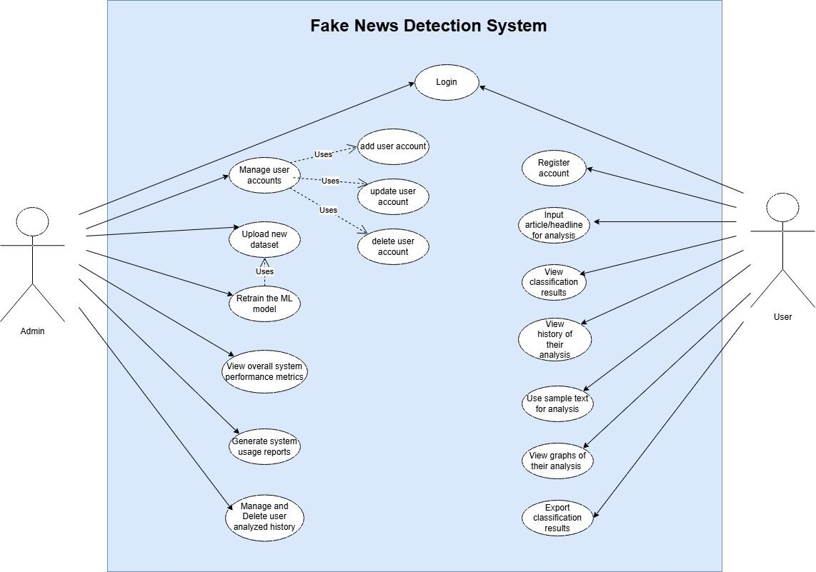

1.6.2 USAGE SCENARIOS:

Use Case Title | Manage user accounts
Use Case ID | UC-01
Actors | Admin
Description | The admin will be able to add, edit or delete user accounts for the system.
Pre-condition | Admin must be logged in first in the system.
Actions | - The admin logs into the system.  - The admin clicks on the Manage user accounts tab.  - The admin selects Add user/Edit user/Delete user  If the admin selects Add user or Edit user then they fill a form to add or edit the user account in the system.  - Save changes.
Post-condition | User data is updated in the system
Alternative Paths | The system shows an error if the user already exists.
Exception | Database is unavailable.
Author | Muhammad Tayyar Hussain BC220201723

Use Case Title | Upload new dataset
Use Case ID | UC-02
Actors | Admin
Description | The admin uploads a new CSV dataset file for model retraining in the system.
Pre-condition | The file must be in CSV format
Actions | - The admin logs into the system.  - The admin selects a file for model retraining.  - The admin uploads the file in the system.  - The system validates whether the uploaded file is in CSV format.  - If it is in CSV format then it is stored in the system.
Post-condition | Data is successfully stored for model retraining.
Alternative Paths | If format validation fails, then an error message will be shown to the admin to re-upload the dataset file in CSV format.
Exception | Incorrect or corrupted file format uploaded.
Author | Muhammad Tayyar Hussain BC220201723

Use Case Title | Retrain the ML model
Use Case ID | UC-03
Actors | Admin
Description | The admin retrains the machine learning model on the system using the dataset uploaded by him in UC-02.
Pre-condition | The dataset must be uploaded and stored in the system before model retraining.
Actions | - The admin logs into the system.  - The admin navigates to the Model retraining tab.  - The admin clicks on the Retrain model button.  - The system will start the retraining process and display a progress or a message indicating that the model is being retrained.
Post-condition | The system generates and updates performance metrics after retraining completes, saves the updated model for future predictions  and then displays a message to show that model retraining was successful.
Alternative Paths | If model retraining takes too much time then the system will show a message.
Exception | Model retraining failed.
Author | Muhammad Tayyar Hussain BC220201723

Use Case Title | View overall system performance metrics
Use Case ID | UC-04
Actors | Admin
Description | The admin views the overall system performance metrics after retraining.
Pre-condition | The dataset must be uploaded and stored in the system before model retraining.
Actions | - The admin logs into the system.  - The admin navigates to the performance metrics tab and clicks it.  - The system loads the performance metrics and shows it.
Post-condition | The system will show performance metrics to the admin.
Alternative Paths | If there are no metrics available the system will show “No performance data available” message.
Exception | The system fails to load performance metrics.
Author | Muhammad Tayyar Hussain BC220201723

Use Case Title | Generate system usage reports
Use Case ID | UC-05
Actors | Admin
Description | The admin will generate system usage reports such as daily prediction count, active users, etc.
Pre-condition | The system should maintain a record in a database or activity log.
Actions | - The admin logs into the system.  - The admin navigates to the Generate System Usage Report tab.  - The system will export the reports in CSV format.
Post-condition | The system produces system usage reports.
Alternative Paths | The admin selects the wrong date range.
Exception | Failed to export the reports.
Author | Muhammad Tayyar Hussain BC220201723

Use Case Title | Manage and Delete user analyzed history
Use Case ID | UC-06
Actors | Admin
Description | The admin deletes selected or all user analysis history.
Pre-condition | User analysis history should exist in the database or log.
Actions | - The admin logs into the system.  - The admin navigates to the Manage user history tab.  - The admin can then select a few entries to delete or select all entries of the user analyzed history.
Post-condition | The system updates the history in the database.
Alternative Paths | The admin can cancel the deletion process.
Exception | Database write error.
Author | Muhammad Tayyar Hussain BC220201723

Use Case Title | Register account
Use Case ID | UC-07
Actors | User
Description | The user can register a new account with username and password.
Pre-condition | The selected username must be unique and the password must meet the criteria.
Actions | - The user navigates to the user register account button and clicks it.  - The user will enter the details.  - The system will validate these details.  - After validation the system will save these details in the database.  - The user receives a confirmation message.
Postcondition | The user account is created successfully.
Alternative Paths | The system shows a message that your selected password is weak.
Exception | The system shows a message that the username is already taken.
Author | Muhammad Tayyar Hussain BC220201723

Use Case Title | Login
Use Case ID | UC-08
Actors | Admin and User
Description | Both admin and user can log in into the system using their valid credentials.
Pre-condition | - Users must be registered in the system.  - Admin must be registered with administrative privileges.
Actions | - Admin or User navigate to the login page and enter their credentials.  - The system takes these credentials and authenticates them.  - After the authentication the system loads their respective page/dashboard.
Post-condition | The admin or user is logged in.
Alternative Paths | The admin or user enters an incorrect username.
Exception | The admin or user enters an incorrect password.
Author | Muhammad Tayyar Hussain BC220201723

Use Case Title | Input article/headline for analysis
Use Case ID | UC-09
Actors | User
Description | The user enters an article/headline for fake-news detection.
Pre-condition | Input must satisfy the required length to use a fake-news detection system.
Actions | - The user logs into the system.  - The user navigates to input text form and enters the input.  - The user clicks the Analyze button.  - The system takes the input and processes it.
Post-condition | The ML model will predict whether the article/headline is real or fake.
Alternative Paths | If the user enters a very long article.  - The system shows an error that the input text is too long and instructs the user to shorten it.  - Or The system automatically trims the input text.
Exception | The user entered empty text or an unsupported language.
Author | Muhammad Tayyar Hussain BC220201723

Use Case Title | View classification results
Use Case ID | UC-10
Actors | User
Description | The user can see classification/prediction results and confidence scores.
Pre-condition | The user has entered the input and submitted it.
Actions | - The user navigates to the Classification/Prediction result tab and clicks it.  - The system fetches the latest prediction and displays it.
Post-condition | The system displays results as Real or Fake along with the confidence score.
Alternative Paths | No results to show.
Exception | The ML model is not loaded in the system.
Author | Muhammad Tayyar Hussain BC220201723

Use Case Title | View history of their analysis
Use Case ID | UC-11
Actors | User
Description | The user can see a list of all the previously analyzed input.
Pre-condition | The user must be logged in.
Actions | - The user navigates to the analysis history tab and clicks it.
Post-condition | The system displays the history of their analysis.
Alternative Paths | The system shows a message that history is empty for the user.
Exception | Database fetching error occurred.
Author | Muhammad Tayyar Hussain BC220201723

Use Case Title | Use sample text for analysis
Use Case ID | UC-12
Actors | User
Description | The user tests the system using built-in sample text provided.
Pre-condition | - The user logs into the system.  - Sample dataset/text should be provided.
Actions | - The user navigates to test the system tab and clicks it.  - The user selects an article or headline to test it.
Post-condition | The system displays the prediction result (Real/Fake) with the confidence score.
Alternative Paths | The sample text list is empty then the system shows a message No sample text available.
Exception | ML model fails to load.
Author | Muhammad Tayyar Hussain BC220201723

Use Case ID | UC-13
Actors | User
Description | The user views the graphs/charts of their predictions. (of all the previously analyzed input)
Pre-condition | At least one prediction should exist in the system.
Actions | - The user logs into the system.  - The user navigates to the View graphs tab.  - The system fetches the data from the database and generates charts/graphs.  - The system displays these to the user.
Post-condition | The system displays the graphs/charts of their analysis.
Alternative Paths | The system shows a message that no data is available or no graph to show.
Exception | The system throws an error if a graph cannot be generated.
Author | Muhammad Tayyar Hussain BC220201723

Use Case Title | Export classification results
Use Case ID | UC-14
Actors | User
Description | The user exports prediction/classification results to CSV or Excel format.
Precondition | Prediction/Classification history should exist in the system.
Actions | - The user logs into the system.  - The user navigates to the Export results tab and clicks it.  - The system shows the available export options (CSV/Excel).  - The user selects any of the options given.  - The system generates the file in the selected format and downloads it to the user’s device.
Postcondition | The exported file is downloaded successfully.
Alternative Paths | The user cancels the export file.
Exception | The system throws a file export error.
Author | Muhammad Tayyar Hussain BC220201723

1.7 Development Methodology:

1.7.1 Chosen Methodology:

The adopted methodology for this project is the VU Process Model, it is a combination of the Waterfall Model and Spiral Model.

1.7.2 Reasons for Chosen Methodology:

Waterfall Model:
It provides a structured, sequential flow for a project where requirements are well understood and does not change, which ensures that from Requirements to Deployment follow a disciplined order.
Each phase of the waterfall model is heavily documented before going to the next phase.

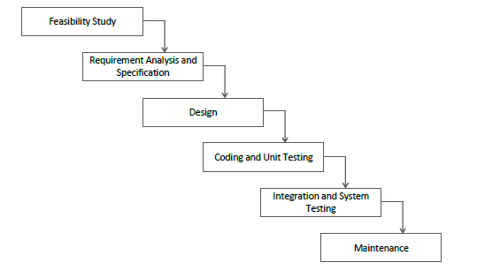
Waterfall Model

Spiral Model:
The spiral model is a risk-driven software development process model.
It adds risk assessment, allows cyclic refinement, and provides frequent feedback loops.
All of the mentioned characteristics above are suitable for the Machine Learning model development, where experimentation is required.

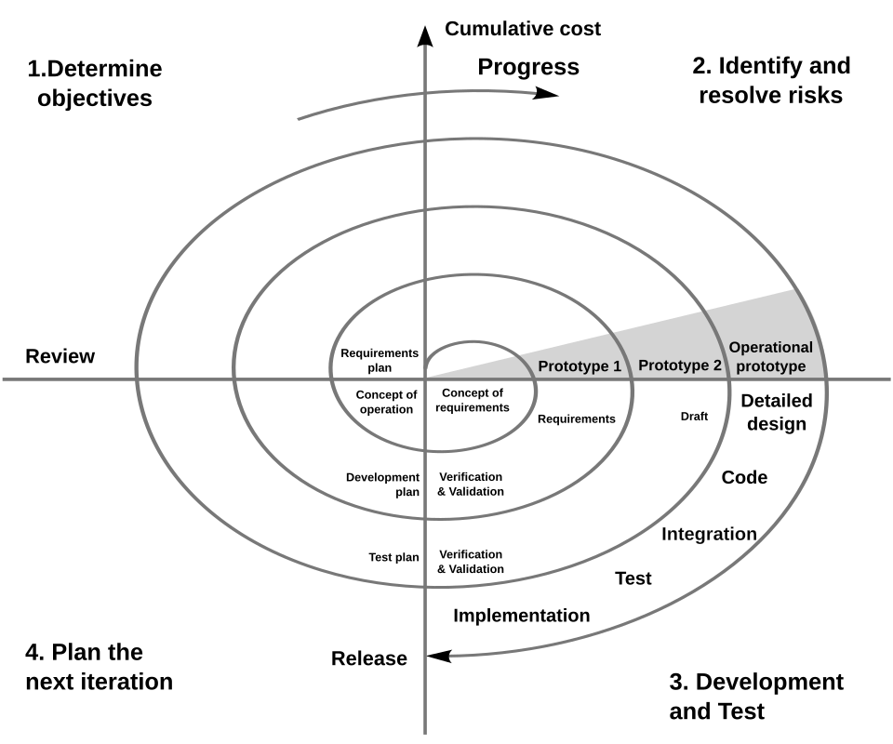
Spiral Model

VU Processes Model:
For the development of this project VU Process Model is followed.
The Waterfall Model component will provide a clear sequence of phases.
Feasibility study, Requirements analysis, Design, Coding, Testing, Integration, Deployment, and Maintenance, which ensures that each stage is completed with proper deliverables.
The Spiral Model component will provide a loop in the whole project life-cycle, which allows early identification and mitigation of risks, in our case, continuous evaluation of the ML model’s performance, and improvement of it through feedback from the prototypes.
By combining these process models, it ensures a balance between systematic project development and the flexibility required for experimentation, especially in Machine learning model training.

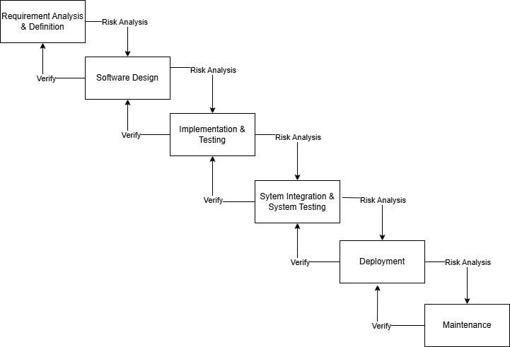
VU Process Model

1.7.3 Work Plan (Gantt Chart):
Weekend days are considered off in this graph.
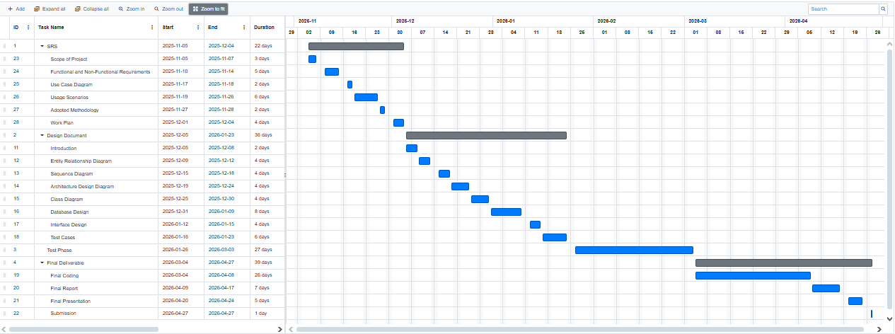

1.7.4 Project Schedule (Submission Calendar):
Originally Final Deliverable end date was 28 April, 2026.
Now it is 11 May, 2026.
The project is completed according to the above plan and date which is 28 April.
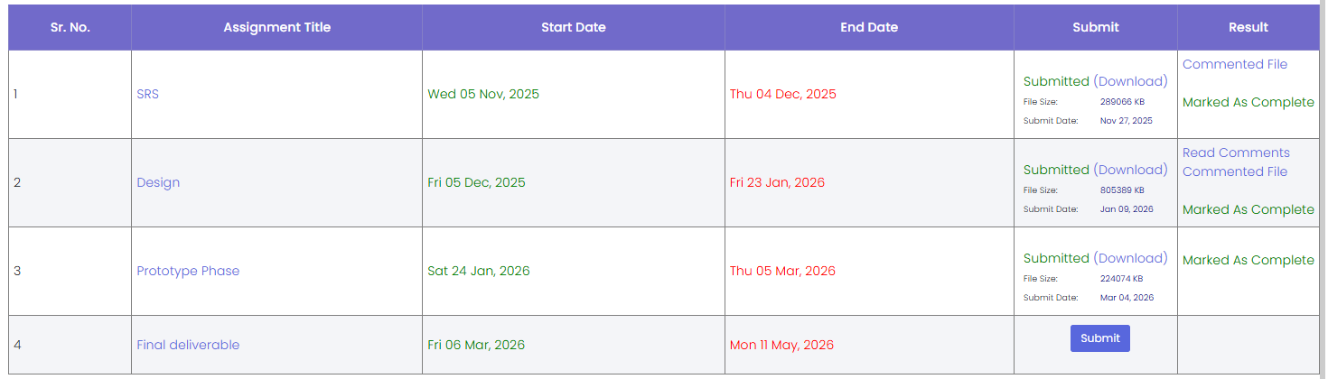

CHAPTER 2
Designing the Project

2.1 Introduction:
The software design describes the detailed system design of the Fake News Detection
System, according to the specified requirements above or in the SRS document.

2.2 Purpose:
The main purpose of the software design is to translate user requirements into a well-defined technical plan, which will be used as a blueprint during the implementation/coding phase.

2.3 Scope:
Software Designing or Design document includes:

- An Entity Relationship Diagram (ERD) is used to model the system data structure.
- Sequence diagrams to show the interaction between actors and different components of the system,
- A Tiered architecture design diagram to show how the overall bigger components of the system are organized and their physical and logical partitioning.
- A Class diagram to define smaller system components and abstract entities from which instances of different classes are realized.
- A Database design diagram to define the actual tables in the DBMS system.
- User Interface designs (GUI) to visualize how the user will interact with the most important parts of the system.
- Test cases to validate and verify each use case scenario that was defined in the SRS document.

The design phase plays a very big part in the entire software development life cycle because it ensures that the system components are logically well defined, technically feasible, and properly aligned with user requirements before actual coding begins.

By identifying the system entities, their relationships, and architectural layers at this stage, the risk of introduction of major errors or defects is significantly reduced, making the system development easier and easier to maintain, and indirectly the cost of development is reduced.

For this project, the design phase is critically important because it integrates machine learning models with a web application. It will also ensure that all system components are clearly defined and properly connected with each other.

Overall, this Software Design phase or SDD serves as a reference point for developers, testers, and project managers, ensuring consistency between the SRS and the final implemented system while improving maintainability and other non-functional requirements.
2.4 Definitions, Acronyms and Abbreviations:

SDD | Software Design Document.
ERD | Entity Relationship Diagram.
GUI | Graphical User Interface.
DBMS | Database Management System.
Pass/Fail | Status indicating whether a test case succeeded or failed.
UC | Use Case (e.g., UC-01).
TC | Test Case (e.g., TC-01).

2.5 Architectural Representation (Architecture Diagram):

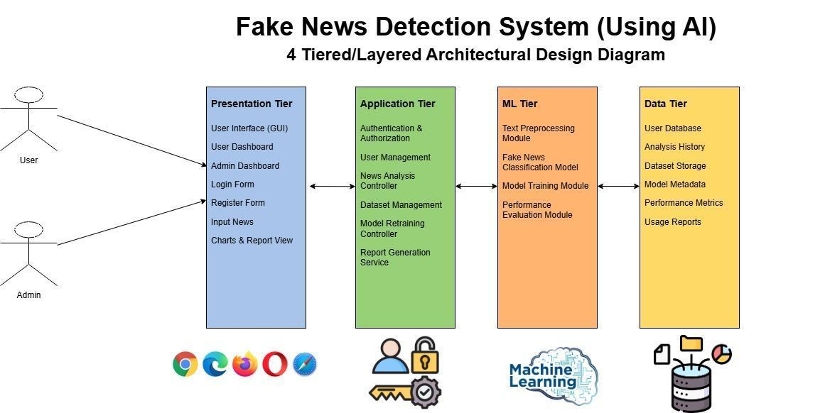

2.6 Dynamic Model: Sequence Diagrams:

2.6.1 Sequence diagram of UC-01 Manage user accounts:

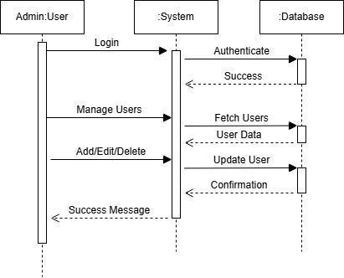

2.6.2 Sequence diagram of UC-02 Upload new dataset:
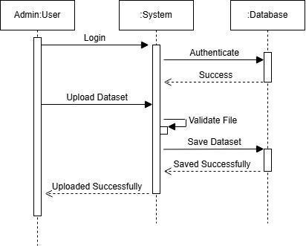

2.6.3 Sequence diagram of UC-03 Retrain the ML model:

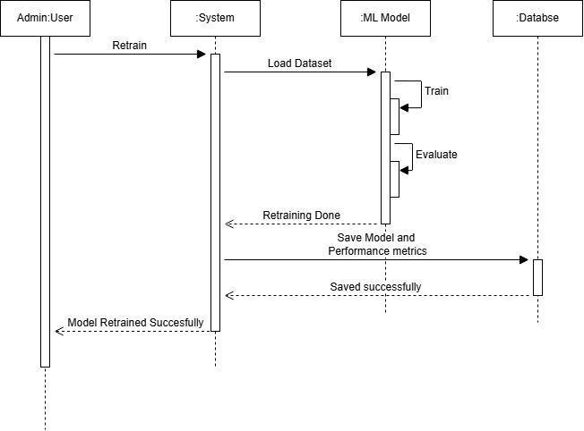

2.6.4 Sequence diagram of UC-04 View overall system performance metrics:
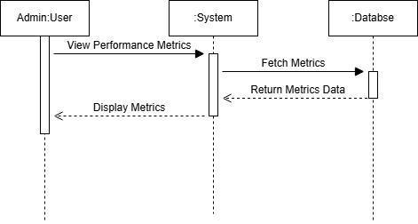

2.6.5 Sequence diagram of UC-05 Generate system usage reports:

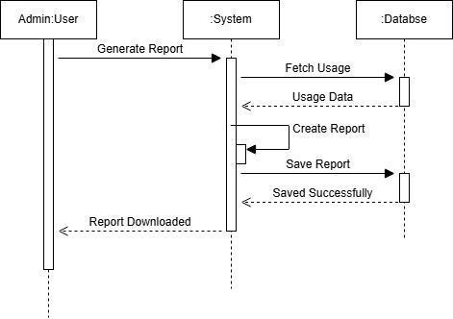

2.6.6 Sequence diagram of UC-06 Manage and Delete user analyzed history:

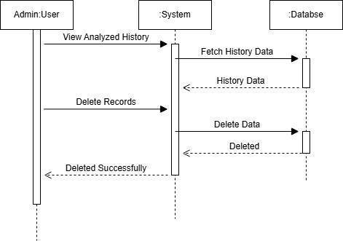

2.6.7 Sequence diagram of UC-07 Register account:
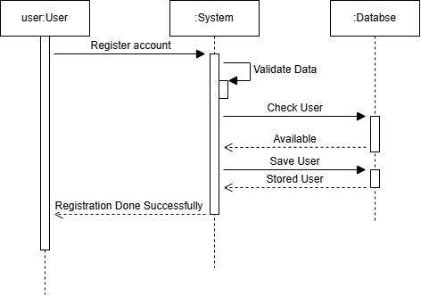

2.6.8 Sequence diagram of UC-08 Login:

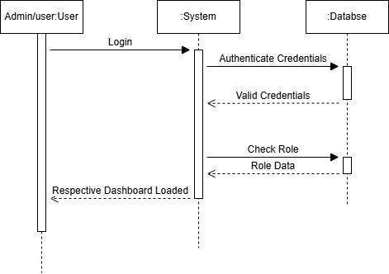

2.6.9 Sequence diagram of UC-09 Input article/headline for analysis:

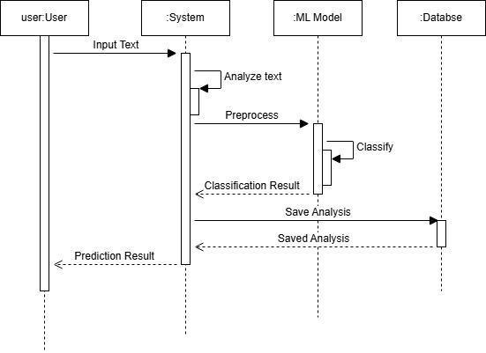

2.6.10 Sequence diagram of UC-10 View classification results:
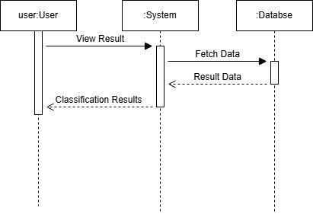

2.6.11 Sequence diagram of UC-11 View history of their analysis:

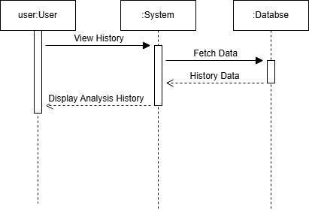

2.6.12 Sequence diagram of UC-12 Use sample text for analysis:
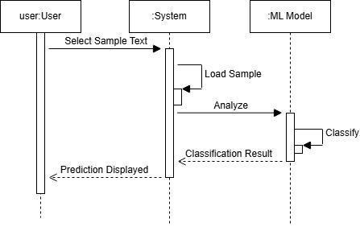

2.6.13 Sequence diagram of UC-13 View graphs of their analysis:

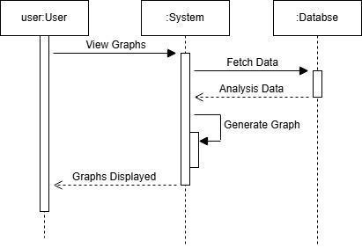

2.6.14 Sequence diagram of UC-14 Export classification results:

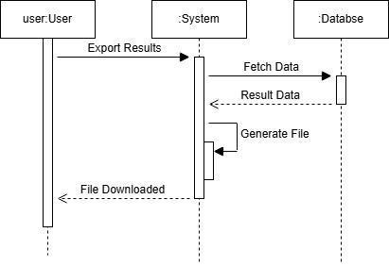

2.7 Object Model/Logical Model: Class Diagram:

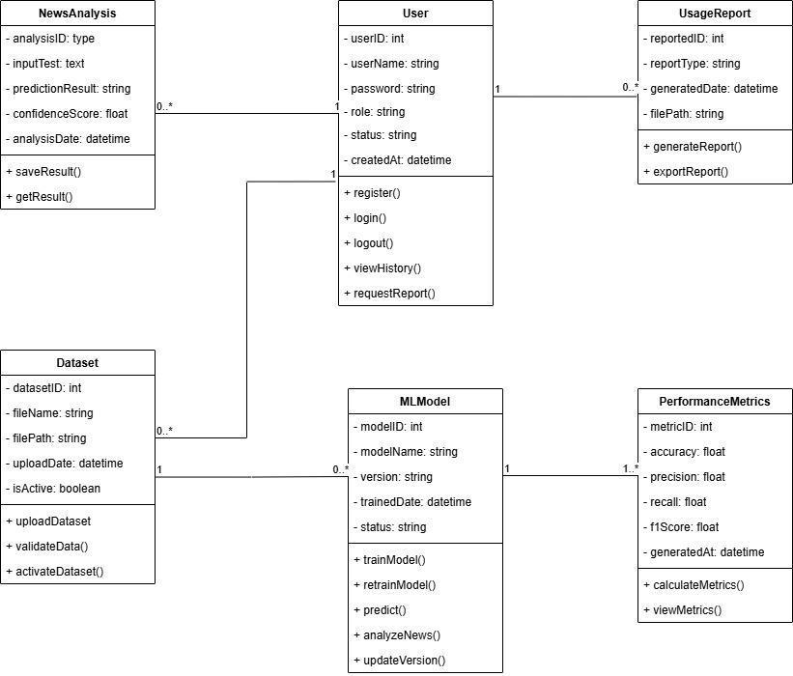

2.8 ER and Database Model (Entity Relationship and Database Diagram)
Both are updated from the Design Document.

2.8.1 Entity Relationship Diagram:

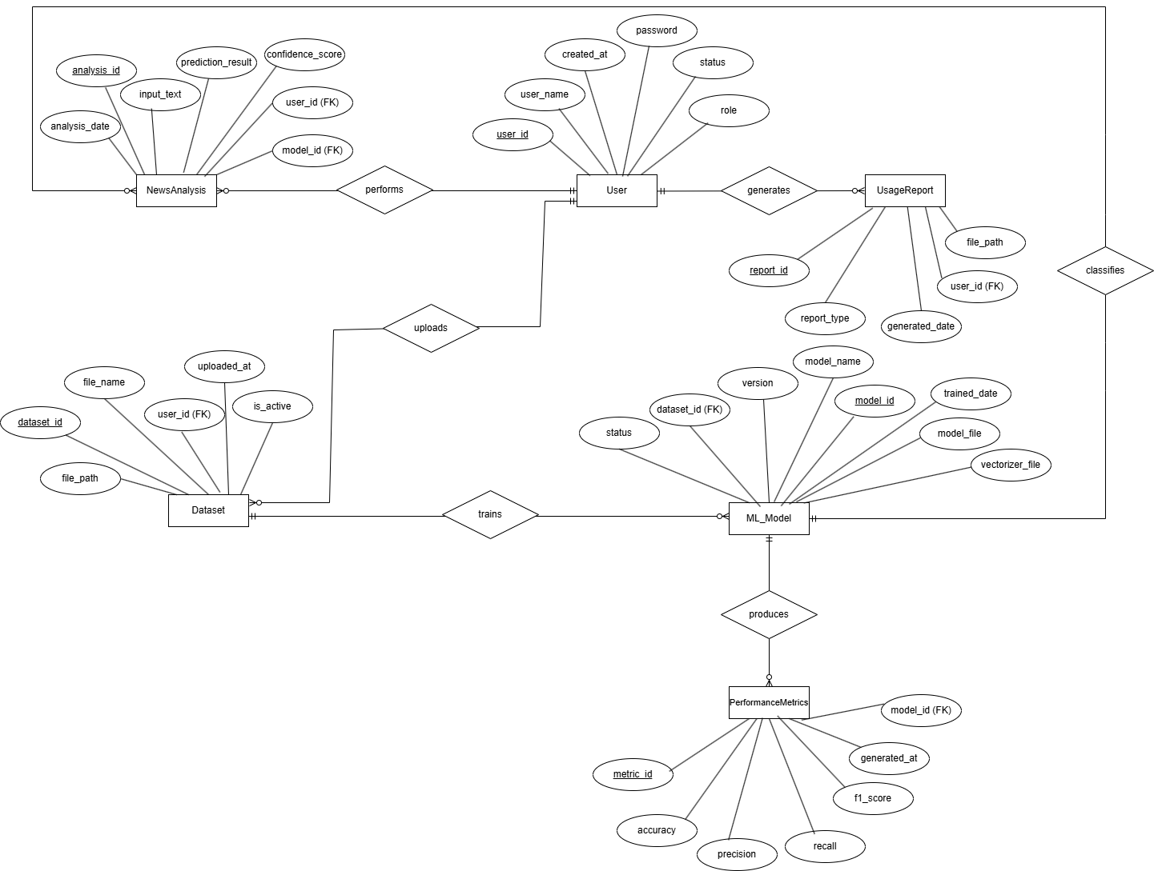

2.8.2 Database Diagram:
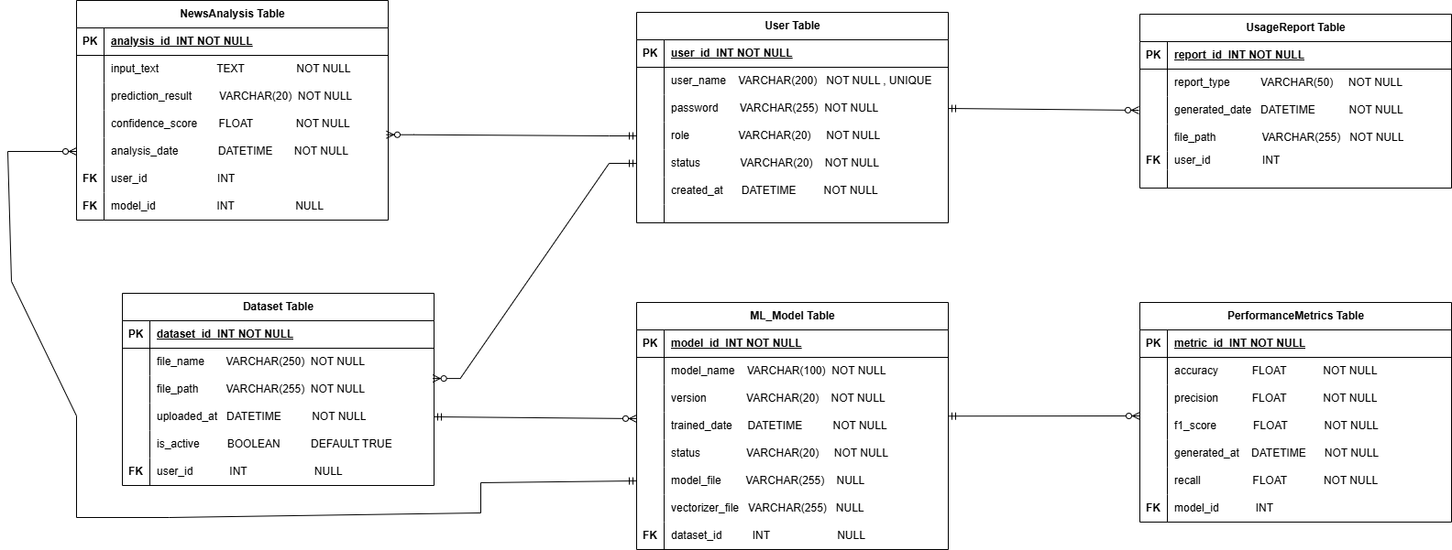

2.9 Graphical User Interfaces:

2.9.1 Landing Page:

2.9.2 Login Page:
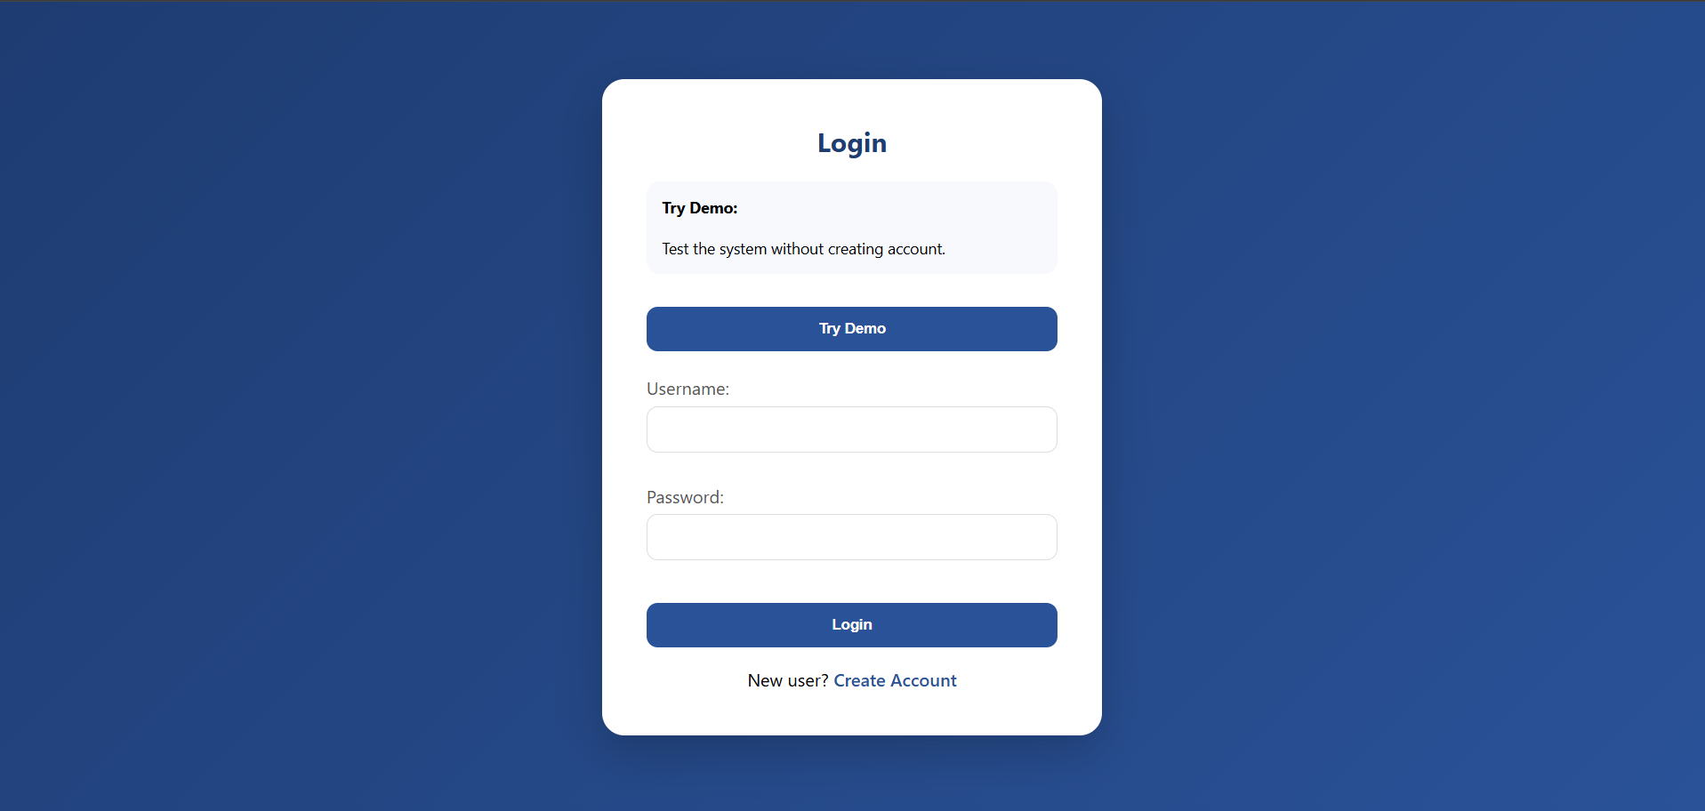
2.9.3 Registration Page
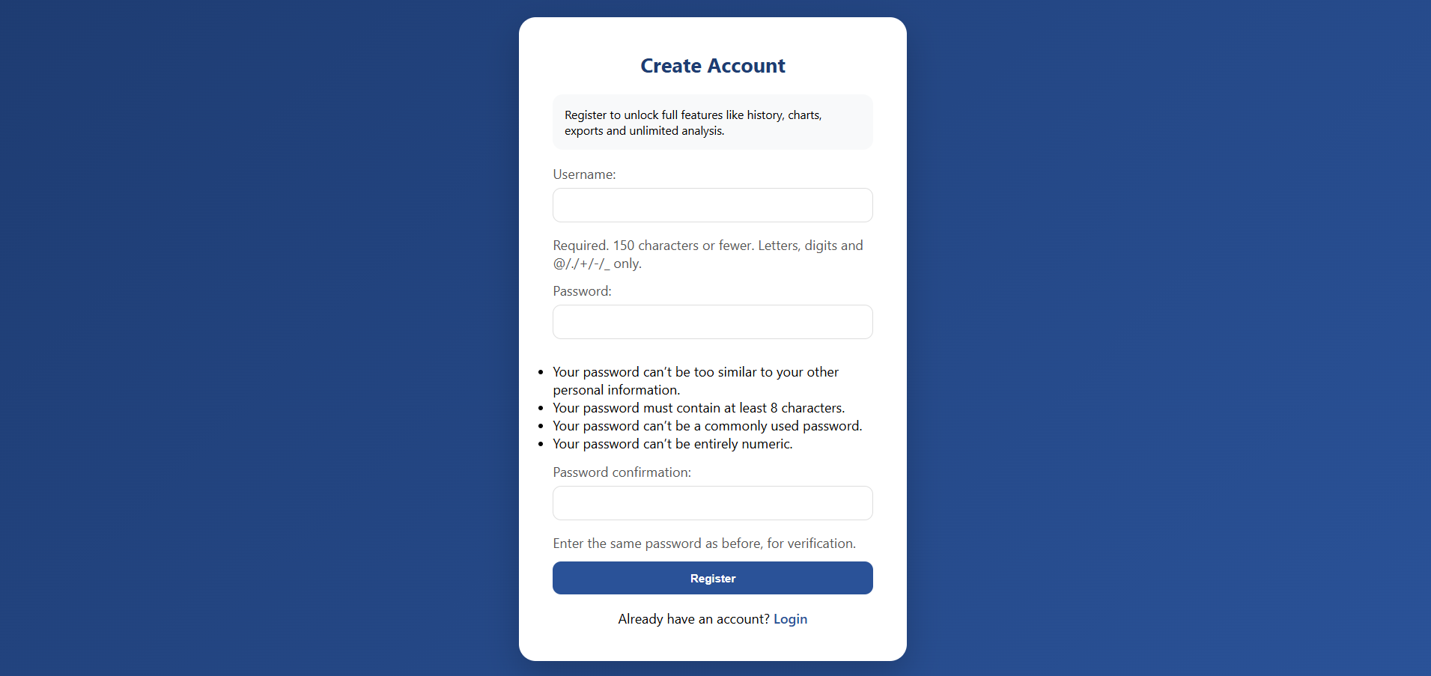

2.9.4 Try Demo Page:
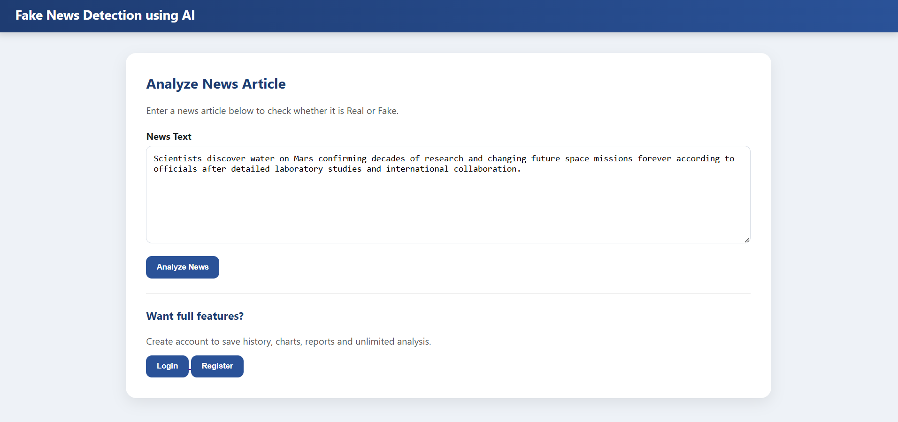

2.9.5 Try Demo Page (on provided test data):
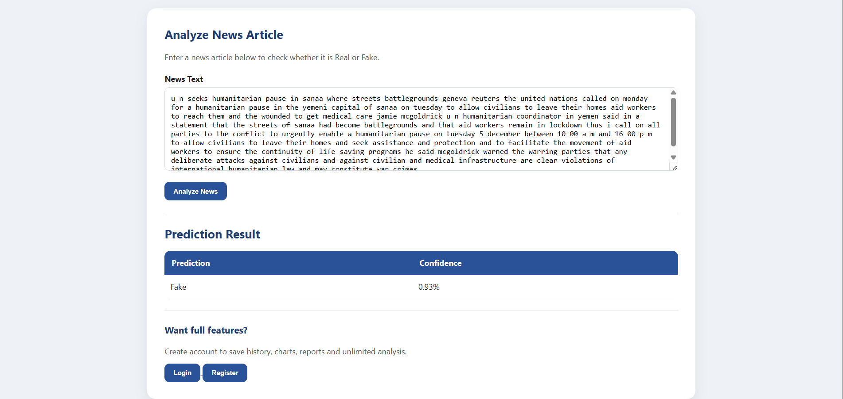
2.9.6 Try Demo Page (on user provided custom news data):
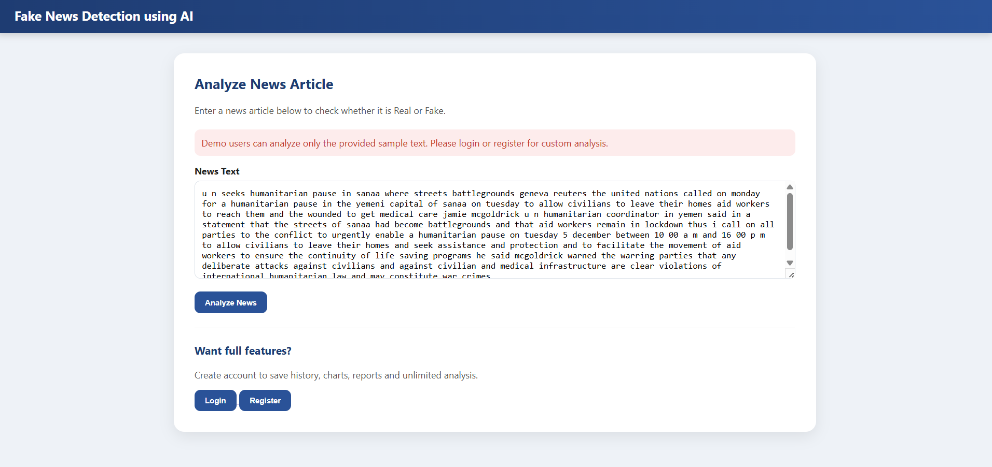

2.9.7 Home Page of Registered User (with news analysis result):
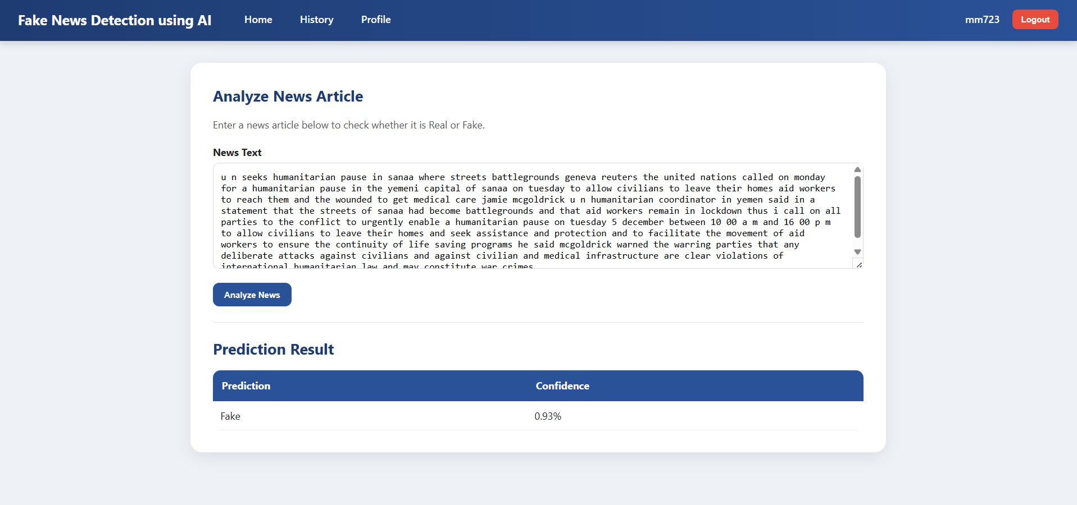

2.9.8 Prediction History Page of Registered User:
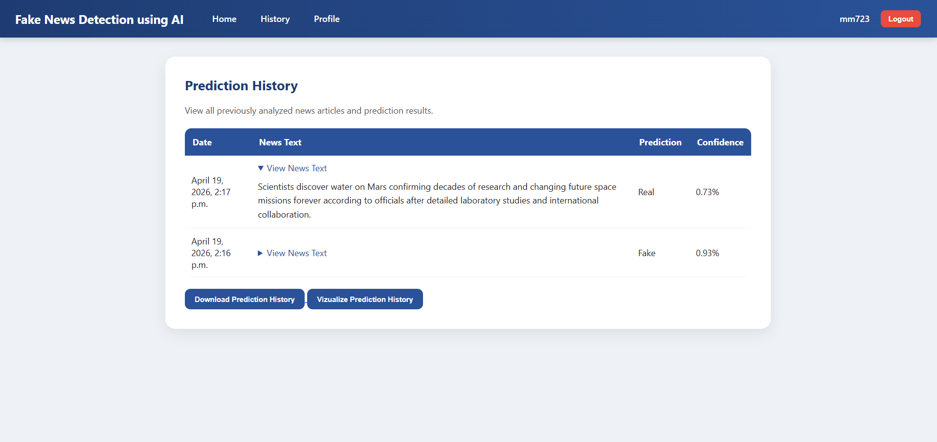

2.9.9 History Chart/Graph Page to Visualize Prediction history:
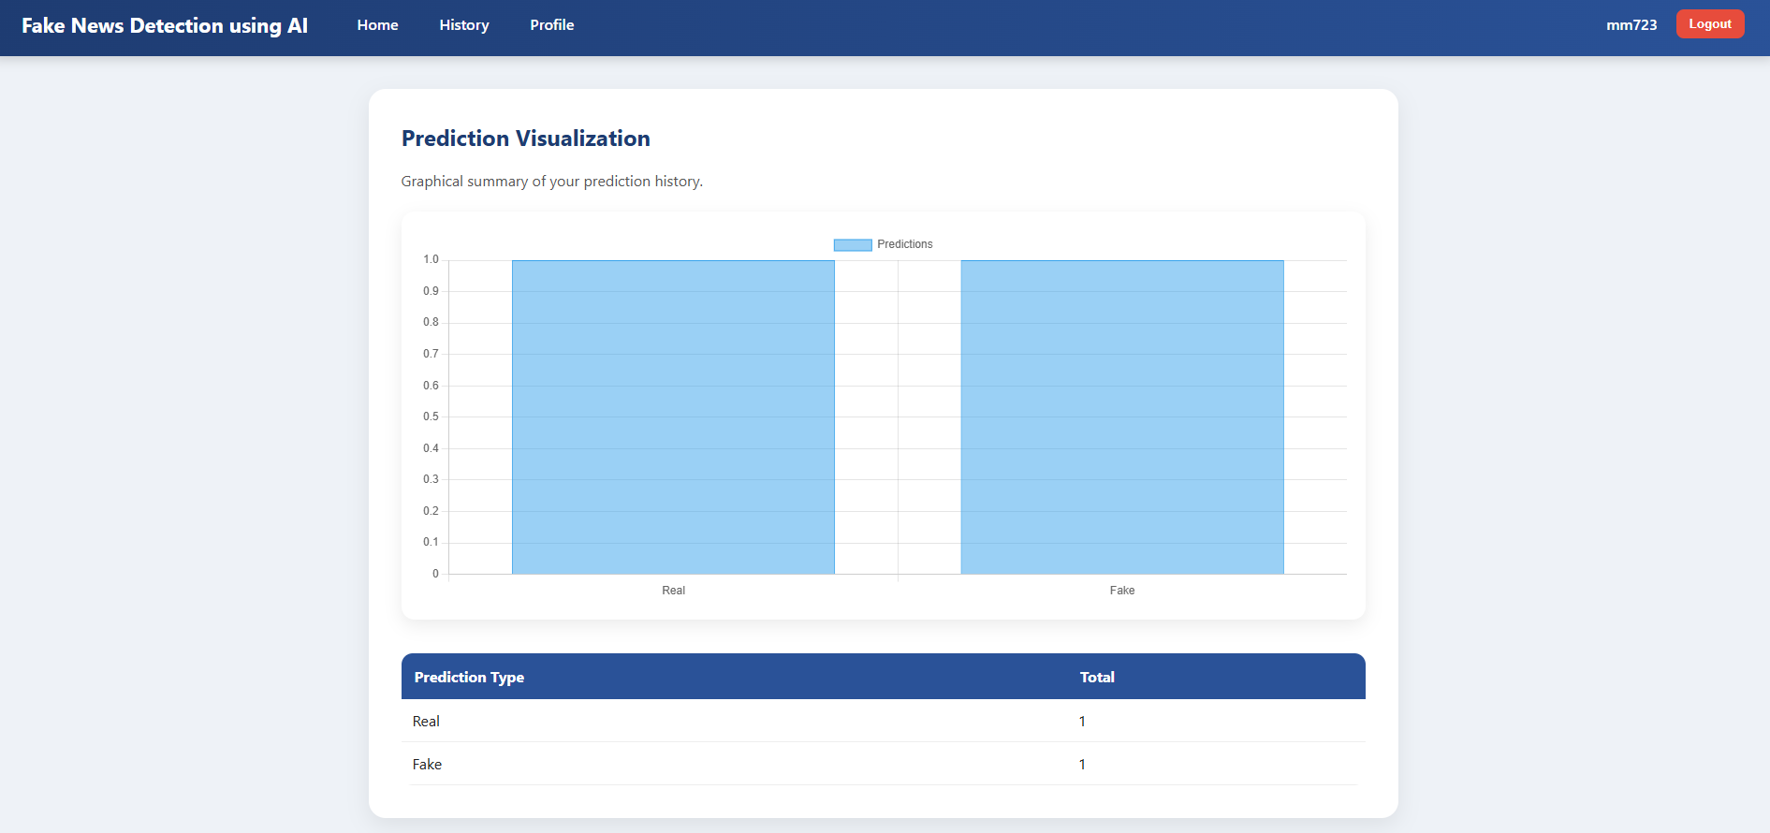

2.9.10 Profile Setting Page (for changing username and password):
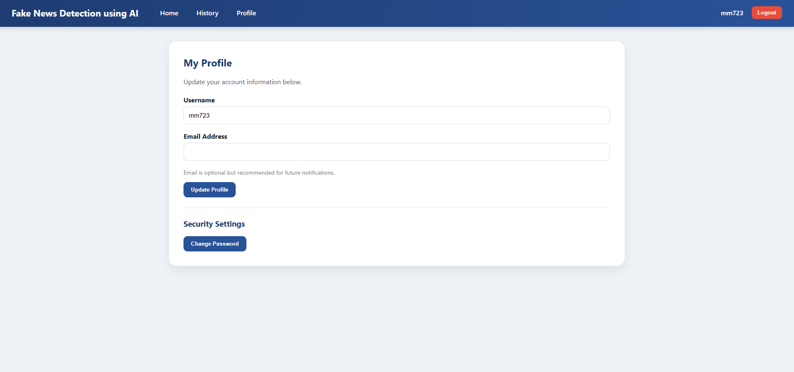

2.9.11 Change Password Page:
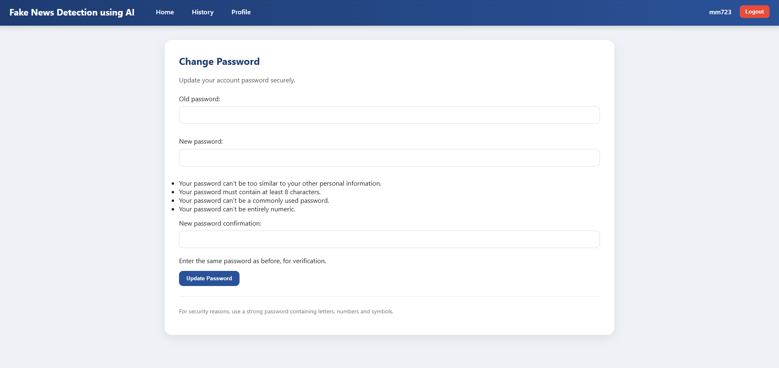

2.9.12 Admin Panel Page:
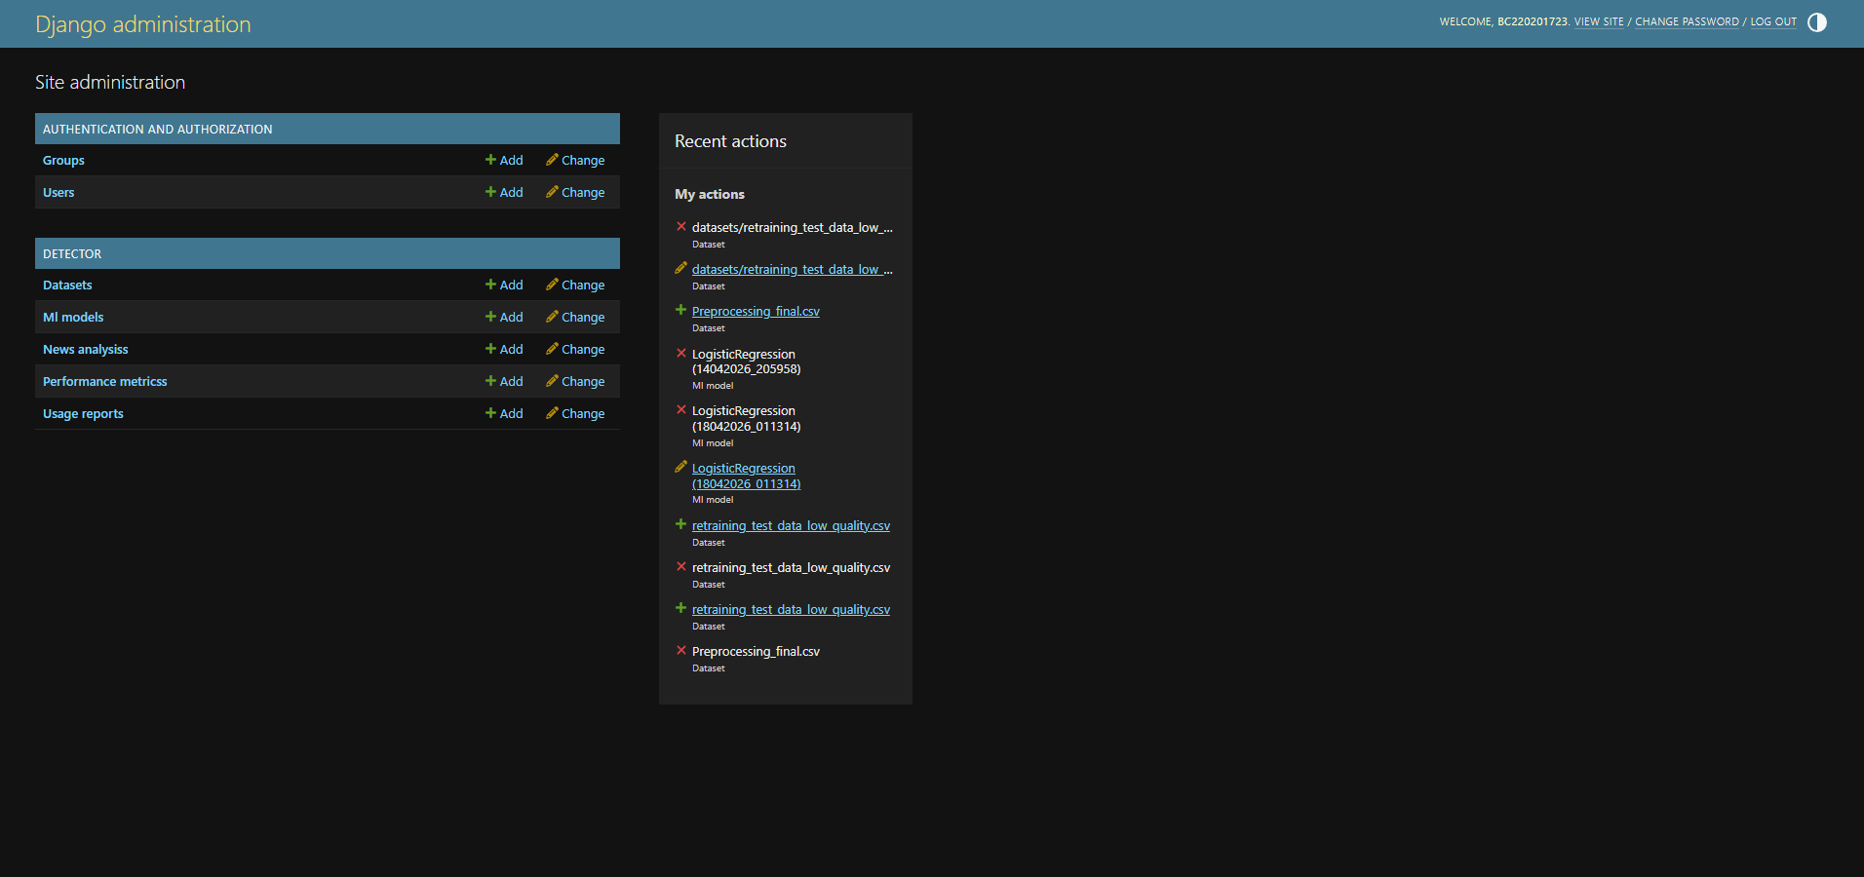

2.9.13 Admin Home Page:
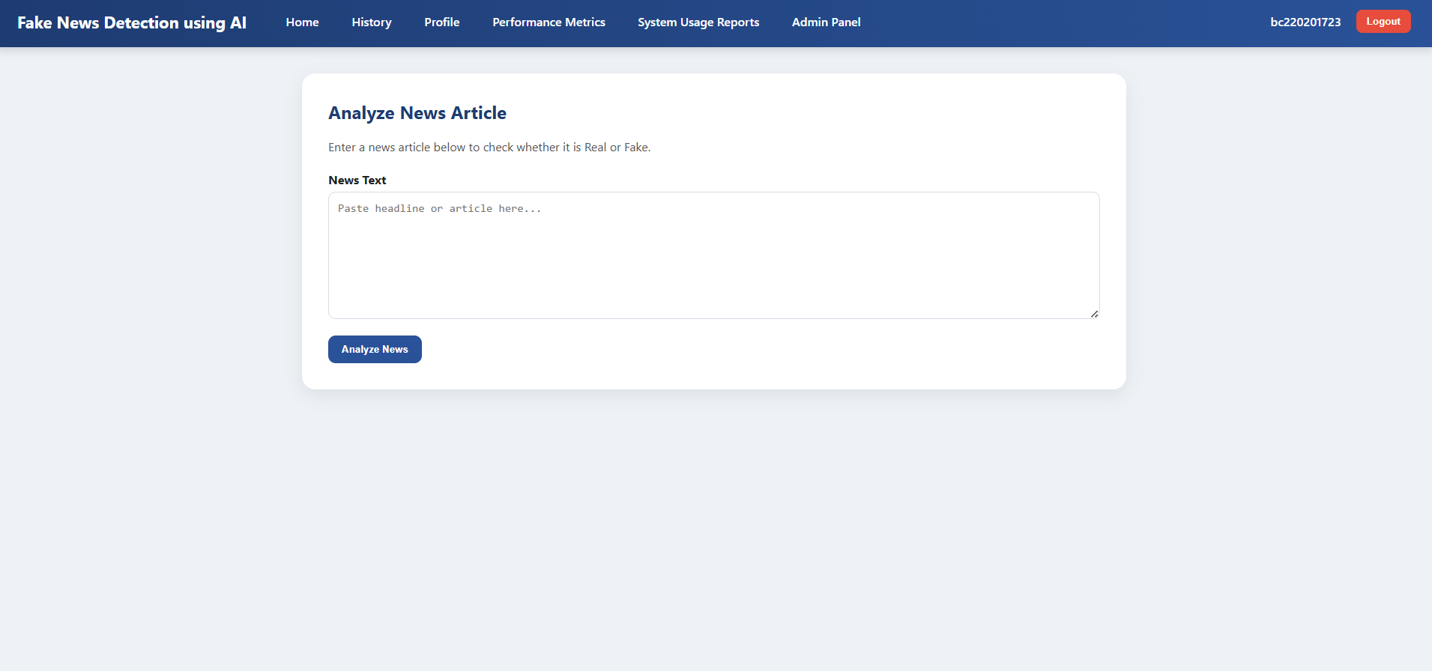

2.9.14 Admin Performance Metrics Page (with Retrain Model button)
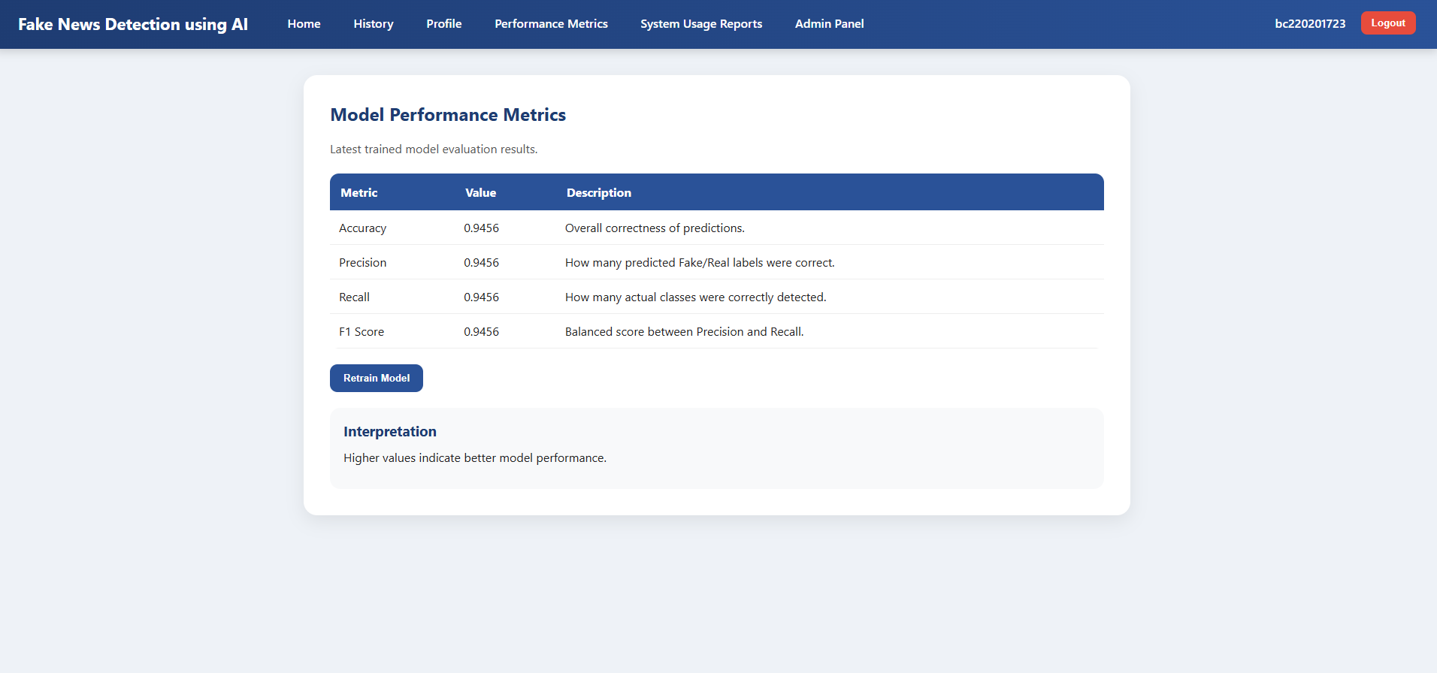

2.9.15 Admin Performance Metrics Page (when Retrain Model button is clicked):
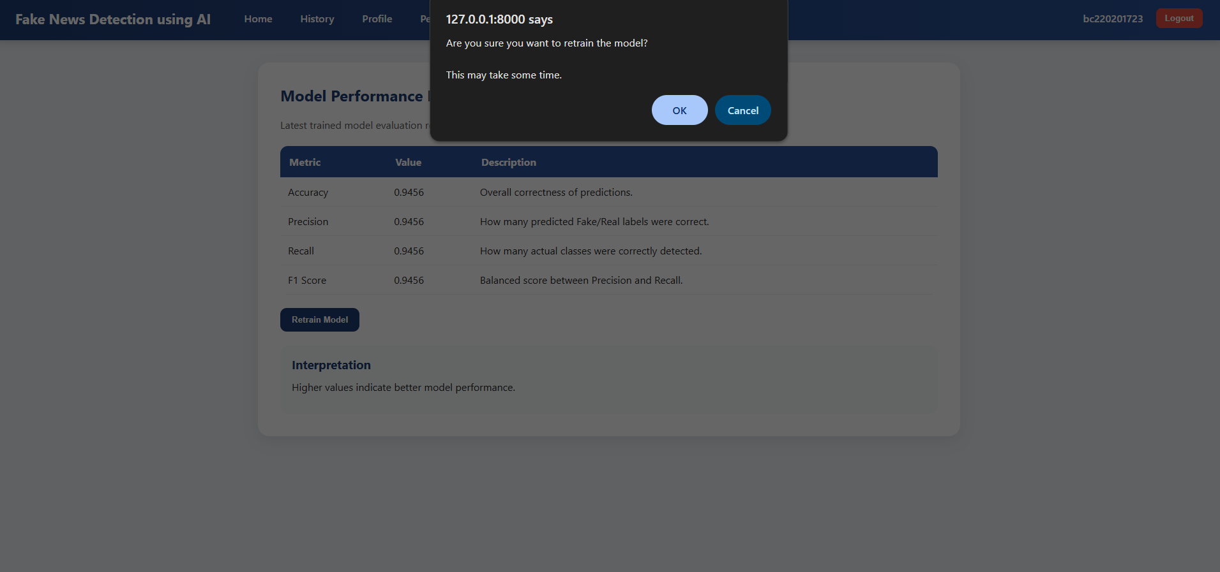

2.9.16 Total System Usage Report Page:
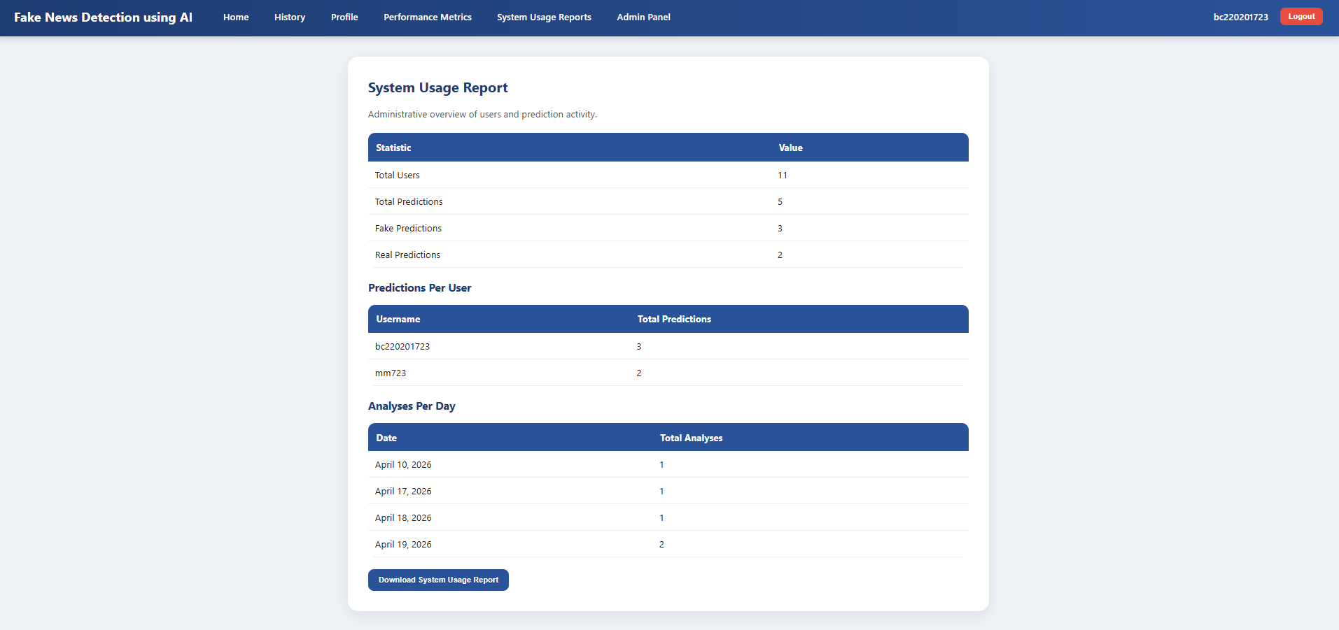

2.9.17 User Management Page (in admin panel):
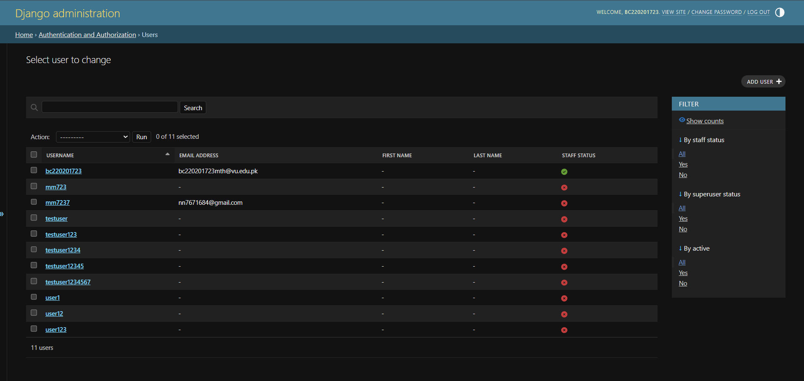
2.9.18 ML Model Page (for model details and advance configurations):
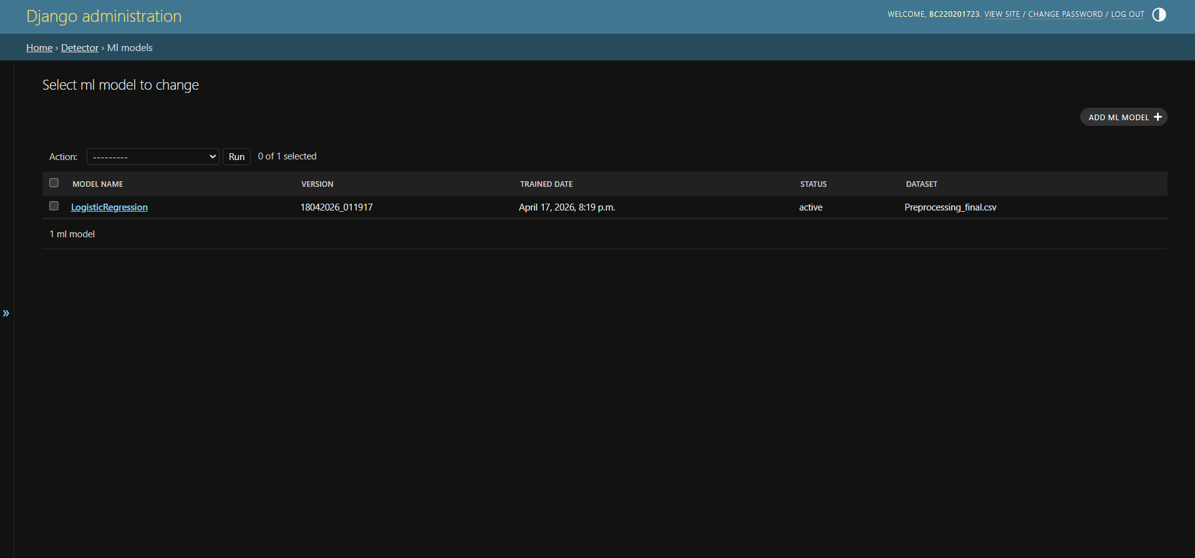

2.9.19 News Analysis Management Page (in admin panel):
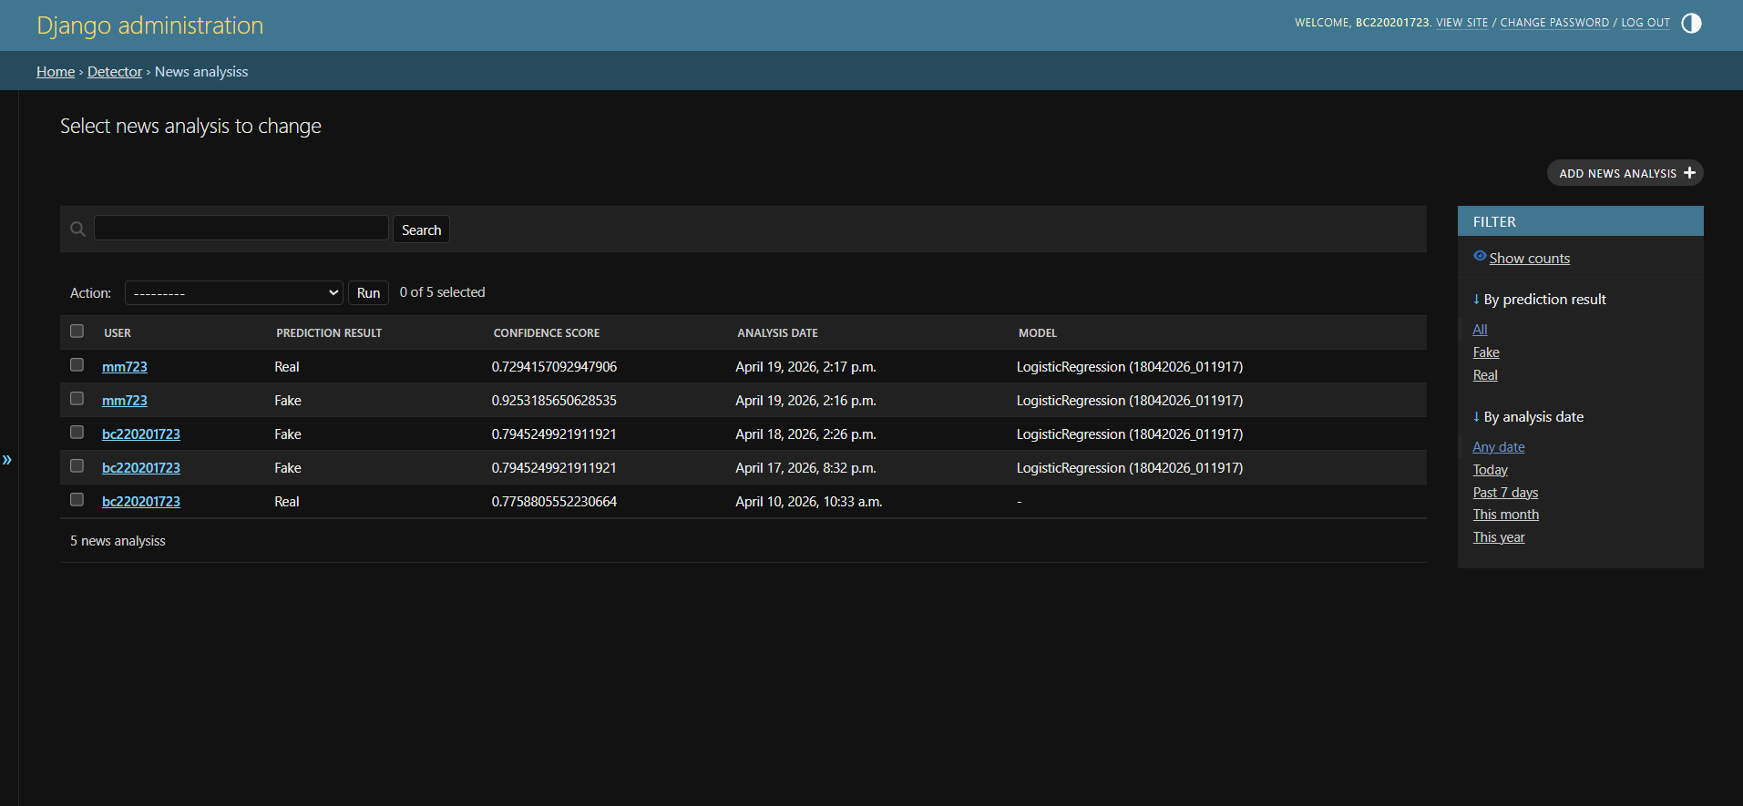

2.9.20 Detailed System Performance Metrics (in admin panel):
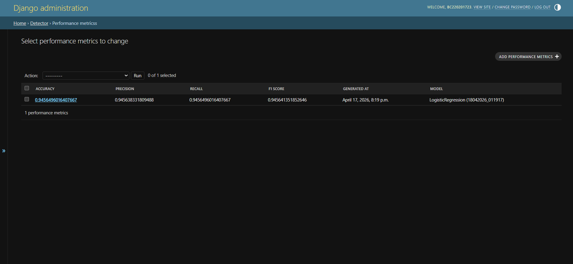

2.9.21 System Usage Report Download History (in admin panel):
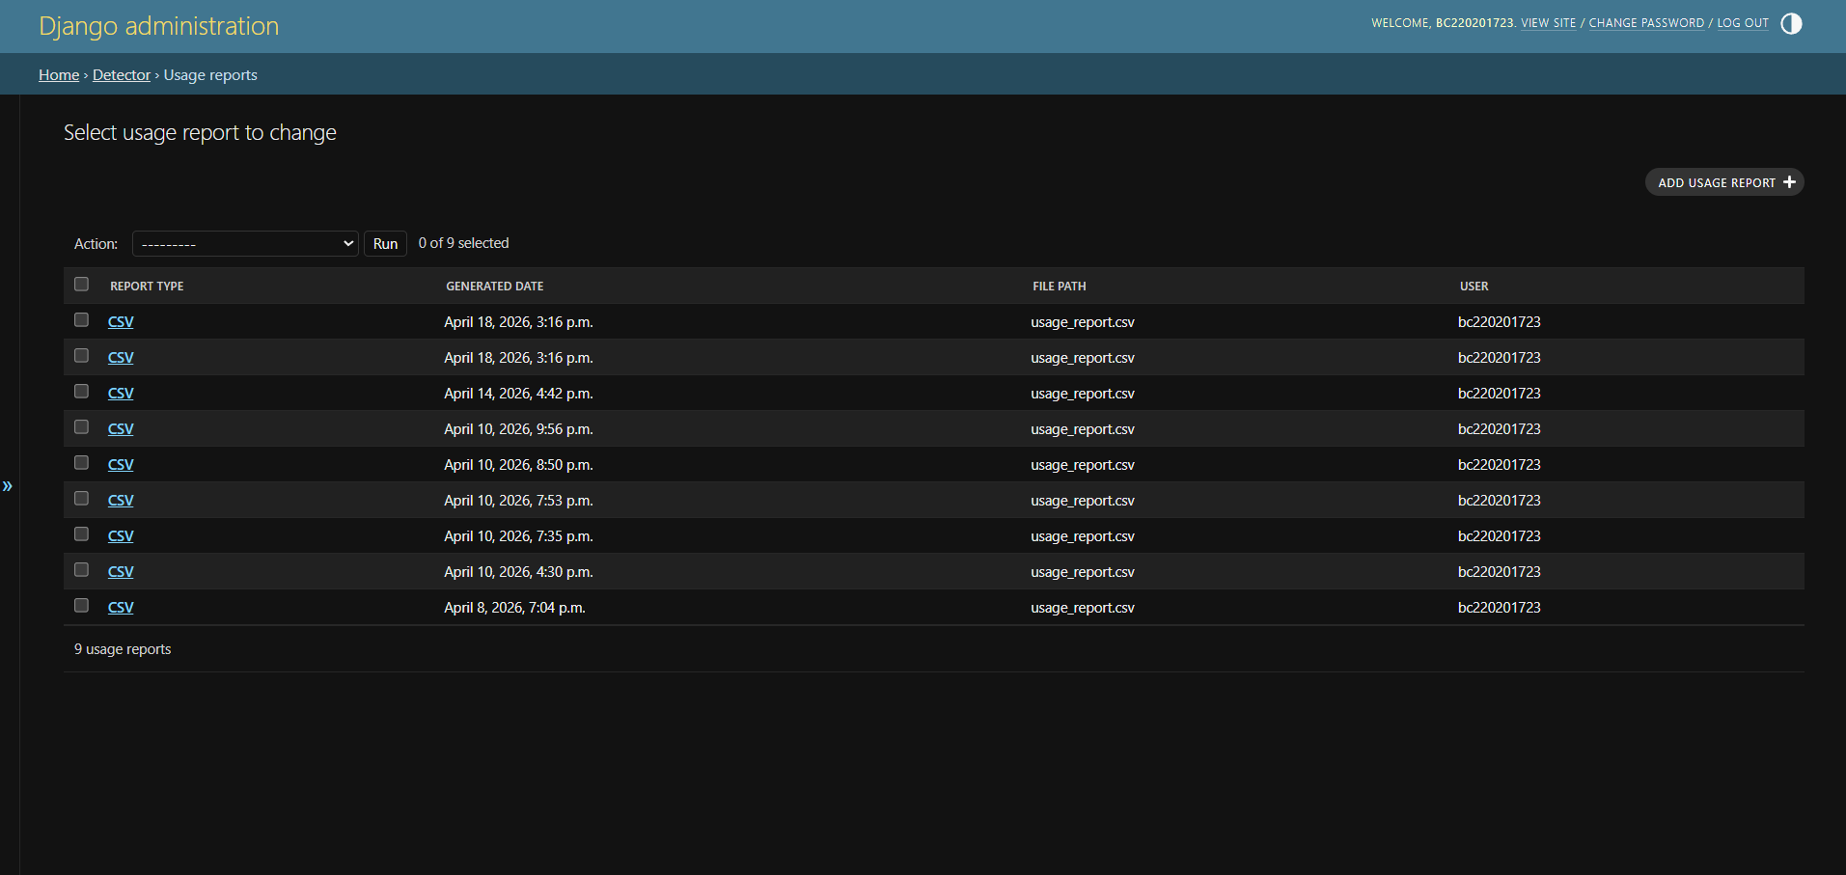

2.9.22 Dataset Management Page (in admin panel):
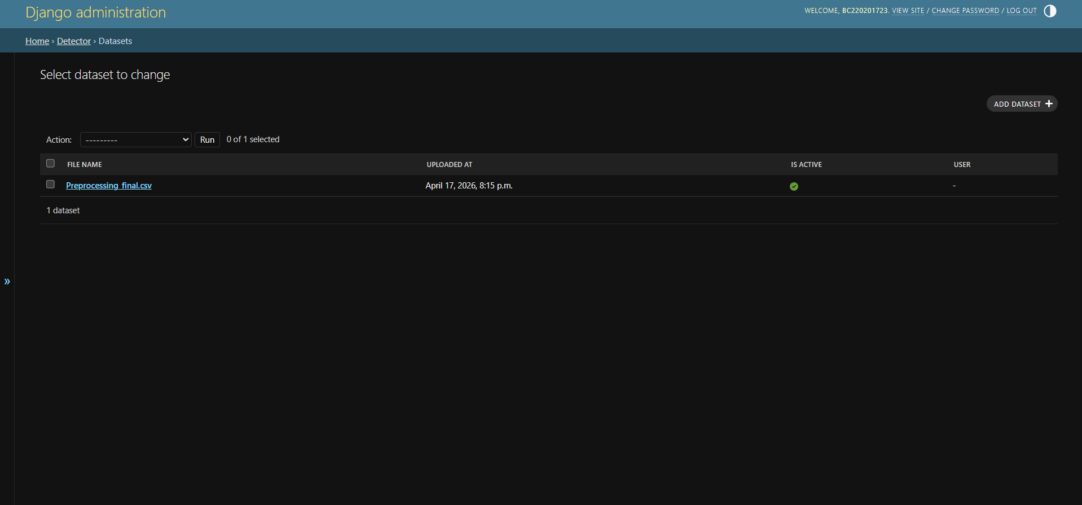

CHAPTER 3
Development

3.1 Introduction:
This chapter describes the practical development of the Fake News Detection Using AI system. After completing the requirement analysis and software design phases, the system was developed as a web-based application using the Django framework with integrated machine learning for fake news detection.

The development phase focused on transforming the software design into a fully functional system that allows users to analyze news articles/headlines and receive predictions as Real or Fake, along with a confidence score. Also, for admin(s), the features were implemented for user management, dataset upload, model retraining, system management, and report generation.

This chapter tries to explain the actual coding and deployment activities carried out during the project, including the tools used, dataset preparation, model training, web application implementation using Django, system testing and final system performance after performing all the development activities.

3.2 Purpose:
The purpose of the development/coding phase is to present how the software design was transformed into a working software solution. It describes the technologies, methods, and implementation steps used to develop the fake news detection system.

This chapter also demonstrates the practical integration of a machine learning model into a web application and highlights how the final system meets the objectives defined during the requirements gathering and analysis phase.

3.3 Scope:
The scope of this development/coding phase is to cover the complete implementation of the Fake News Detection Using AI project. It includes dataset preparation, model training, creation of user and admin panels, physical database design and integration, user interface development, testing, and final deployment.
In short implementations of every single requirement specified in the SRS or Software Requirement phase.

This phase specifically covers:
- Development environment and tools used.
- Dataset preprocessing and preparation.
- Machine learning model training, integration, and evaluation.
- Django web application development.
- User panel features.
- User authentication and security features.
- Prediction history, charts, and export data features.
- Admin panel features, including retraining and reports.
- System testing.

3.4 Definitions, Acronyms and Abbreviations:

IDE | Integrated Development Environment
API | Application Programming Interface
GUI | Graphical User Interface
TF-IDF | Term Frequency – Inverse Document Frequency
LR | Logistic Regression
SVM | Support Vector Machine
HTML | HyperText Markup Language
CSS | Cascading Style Sheets
JS | JavaScript
URL | Uniform Resource Locator
NLTK | Natural Language Toolkit
JSON | JavaScript Object Notation

3.5 Development Plan (Architecture Diagram):

3.6 Django framework Model-View-Template (MVT) architecture:
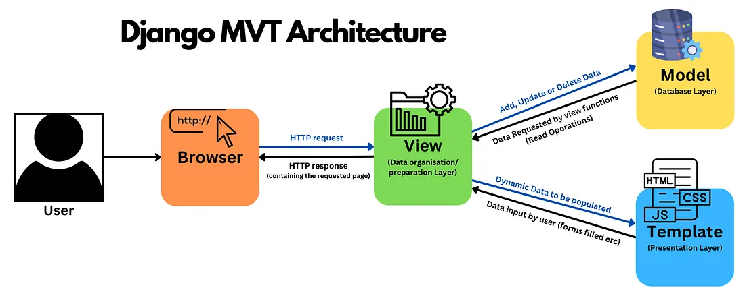
3.7 Difference between traditional MVC architecture and Django MVT architecture:
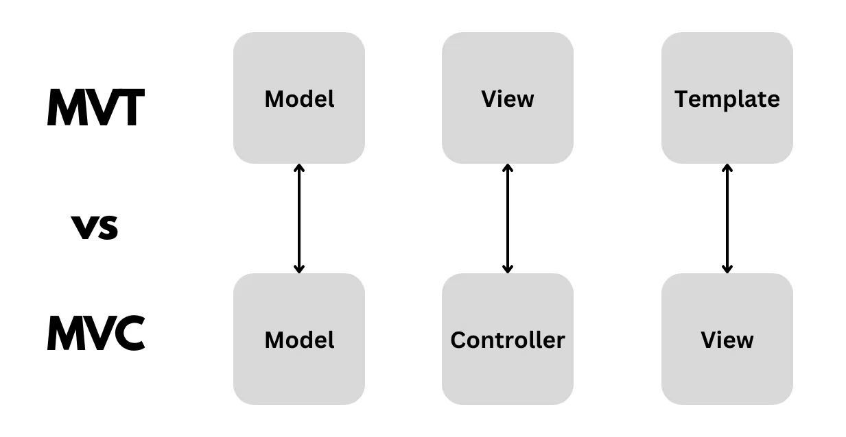

3.8 Development Environment:



3.9 Core Tools and Technologies Used for Development:

Python 3.x | Main programming language used for the development
Django | Web App framework used to develop the fake news detection web interface
Jupyter Notebook | Used for dataset preprocessing, and model experimentations
VS Code | Source code editor used for coding and debugging
SQLite | Database used for storing users, predictions, reports, and model records
Pandas | Used for data loading, cleaning, preprocessing, and CSV file handling
NumPy | Used for some numerical operations
Scikit-learn | Used for lachine learning model training, TF-IDF vectorization, train/test split, and evaluation metrics
Joblib | Used for saving and loading trained machine learning model files
Regex (re) | Used for text cleaning and input validation using pattern matching
Chart.js | JS library used for chart generation in the web application
HTML5 | Used for front-end page structure
CSS3 | Used for styling and page layout design
NLTK | Used for data preprocessing for NLP.
WELFake Dataset | Primary dataset used for fake news model training
FakeNewsNet Dataset | Additional dataset used to improve training data diversity
Google Chrome | Used for testing and running the system

3.10 NLP Workflow Pipeline:
The machine learning part of this project follows a classical NLP workflow for fake news detection. Since fake news detection is based on textual input, the raw text should be transformed into numerical features before model training.

Workflow pipeline consists of the following stages:
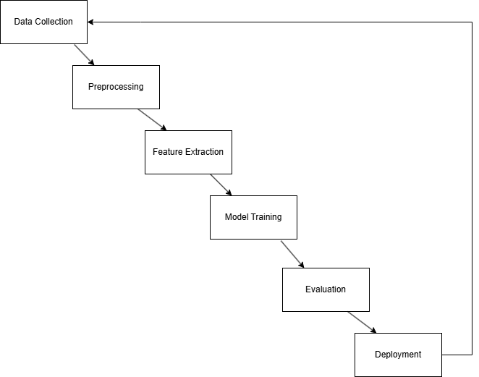

This workflow is implemented using Jupyter Notebook for preprocessing and model experimentation, while the final model retraining and deployment were integrated into the Django web application.
To use the model retraining feature, the training data must be preprocessed offline to achieve higher performance and accuracy.

3.11 Datasets Collection:
The performance of any machine learning algorithm depends heavily on the quality and relevance of the dataset. For this project, I selected two publicly available datasets from Kaggle and combined them to create a larger training dataset.

WELFake Dataset | Main dataset containing fake and real news articles
FakeNewsNet Dataset | An additional dataset used to improve diversity in the training dataset

These datasets contain labeled news rows classified as Real or Fake. After searching and evaluating multiple data sources, only these datasets were selected with the objective of fake news detection.

3.12 Datasets Preprocessing:
Before the model training, both datasets were cleaned and standardized as a necessary data preprocessing procedure to reduce noise, remove inconsistencies, and improve model accuracy and overall performance. After preprocessing and duplicate data removal, the final combined dataset contained 84,950 rows.
Standard NLP preprocessing techniques generally include:
• Tokenization (splitting text into individual words or tokens)
• Lowercasing (converting text into lowercase for uniformity)
• Stopword Removal (removing common words such as “the”, “is”, and “and”)
• Stemming/Lemmatization (reducing words into their base form, e.g.,
running → run)
• Punctuation Removal (eliminating unnecessary symbols and noise)
Some preprocessing tasks such as tokenization and removing stopword were also handled during the feature extraction phase using TF-IDF vectorization.
The actual preprocessing steps done in Jupyter Notebook were:
1. Missing values were replaced with empty strings.
2. Title and text columns were combined into a single field called news.
3. All text was converted to lowercase.
4. URLs and HTML tags were removed.
5. Punctuation, unnecessary symbols, and extra spaces were removed.
6. Lemmatization was applied to reduce words to their base form.
7. Empty rows were removed.
8. Duplicate records were removed.
9. Labels were validated and converted into binary classes:
0 = Fake, 1 = Real.
3.13 Feature Extraction:
I used TF-IDF (Term Frequency – Inverse Document Frequency) as my feature extraction method. Machine learning algorithms cannot directly process raw text data. That's why the preprocessed text data is transformed into numerical vectors using TF-IDF.

TF-IDF assigns weights to words based on their importance within a document and across the dataset.
To boost feature quality, these parameters were used:
• Stop word removal (English)
• Maximum features = 7000
• Minimum document frequency = 2
• Maximum document frequency = 0.90
• Sublinear term frequency scaling
• N-gram range = (1,2)

This will allow the model to learn both single words and two-word phrases from the dataset. Bigrams help in capturing meaningful phrases such as breaking news, official statements, and viral claims.

3.14 Model Training:
After feature extraction and the dataset division into training and testing datasets.
The dataset is divided into 80% training data and 20% testing data using stratified sampling. Logistic Regression (LR) was selected as the final classification algorithm.

It provides strong performance in text classification for sparse data, fast training speed on Django, lightweight deployment, and efficient predictions for web applications.
The trained model and vectorizer were saved using Joblib for future use inside the Django web application system.

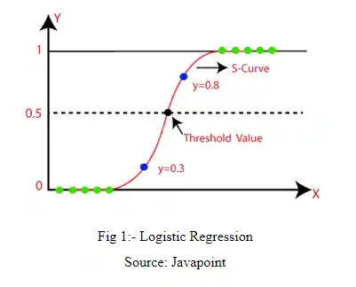

Result of different models based on the same dataset during experimentation.
After conduction some experiments, I continued with Logistic Regression as the deployed model instead of Support Vector Machine for the following reasons:
- Its performance difference compared with Linear SVM was very small.
- It provides strong and balanced performance across Accuracy, Precision, Recall, and F1-score.
- It trains efficiently and is faster for deployment inside the Django web application.
- It is easier to maintain, explain, and integrate compared with more complex alternatives.
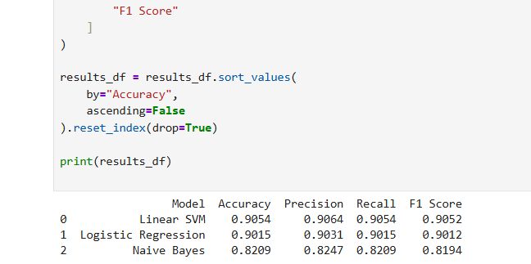

3.15 Model Evaluation:
After training, standard performance metrics were used to measure prediction quality.
Accuracy = 91.44%
Precision = 91.55%
Recall = 91.44%
F1 Score = 91.42%
These results indicate that the system performs reliably for binary fake news classification.

3.16 Model Deployment and Integration:
The final trained model is integrated into the Django web application. Users can enter a news headline or article paragraph through the interface, and the system predicts whether the news is Real or Fake along with a confidence score.

An admin retraining feature is also implemented, allowing new CSV datasets to be uploaded and the model to be retrained directly from the web interface without manual offline coding of the model.
If the model retraining performance metrics are not up to the mark, then the admin can also load the previous model. The rollback feature is implemented in the admin panel.

3.17 Challenges Faced During Development:
During coding for this project, I faced several challenges.
- Trying to find suitable fake news datasets was a major challenge, especially datasets related to Pakistan.
- Publicly available datasets are noisy, have duplicate rows, missing values, and their reliability and authenticity also matter and inconsistent text rows that require preprocessing before model training.
- Trying to achieve higher model accuracy required multiple experiments with preprocessing techniques, feature extraction parameters, and fine-tuning of the model.
- Integrating the machine learning model with the Django framework was the most challenging part of the project, as it required careful handling of model loading, and the retraining feature was also quite challenging.
- Model retraining requires validation of uploaded datasets to ensure that the uploaded dataset is in CSV format, and I also implemented a model rollback feature. If the retraining did not achieve satisfactory performance metrics, the admin can safely rollback to the previous version of the model.
- User management, saving analysis history, visualizing the history through charts/graphs, exporting the analysis data, admin features, and model retraining within one system also increased implementation complexity significantly.
Despite all the challenges mentioned above, all of the project's requirements were successfully completed.

3.18 Future Enhancements:
The current system can be improved in the future during the maintenance phase.
following are some enhancement suggestions:

- Advanced deep learning techniques such as transformer models, BERT, or RoBERTa can be integrated to improve prediction accuracy.
- Manual collection and validation of news articles or headlines that are related to Pakistan in order to make a bigger dataset. This will make the system more localized towards the Pakistani audience.
- Deployment on the cloud to make the system accessible to a larger audience.
- Since most of the general audience uses smartphones, a mobile application version of the system can make the fake news detection more accessible to the public
- Automatic scheduled retraining using MLOps pipelines can also be done to reduce the dependence from the admin for model retraining.

REFERENCES

[1] https://www.djangoproject.com/

[2] https://scikit-learn.org/

[3] https://pandas.pydata.org/

[4] https://numpy.org/

[5] https://joblib.readthedocs.io/

[6] https://www.chartjs.org/

[7] https://matplotlib.org/

[8] https://seaborn.pydata.org/

[9] https://docs.python.org/

[10] Kaggle WELFake Dataset:
https://www.kaggle.com/datasets/saurabhshahane/fake-news-classification

[11] Kaggle FakeNewsNet Dataset:
https://www.kaggle.com/datasets/algord/fake-news

[12] Virtual University of Pakistan – CS504 Software Engineering I Course Material/Handouts

[13] Virtual University of Pakistan – CS605 Software Engineering II Course Material/Handouts

